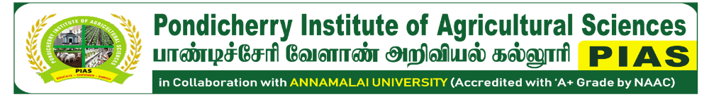
No: 82, Lalitha Nagar, Thavalakuppam, Puducherry – 605 007
📞 9442927204 / 9629026290 🌐 www.pias.org.in ✉ piasagri.cead@gmail.com

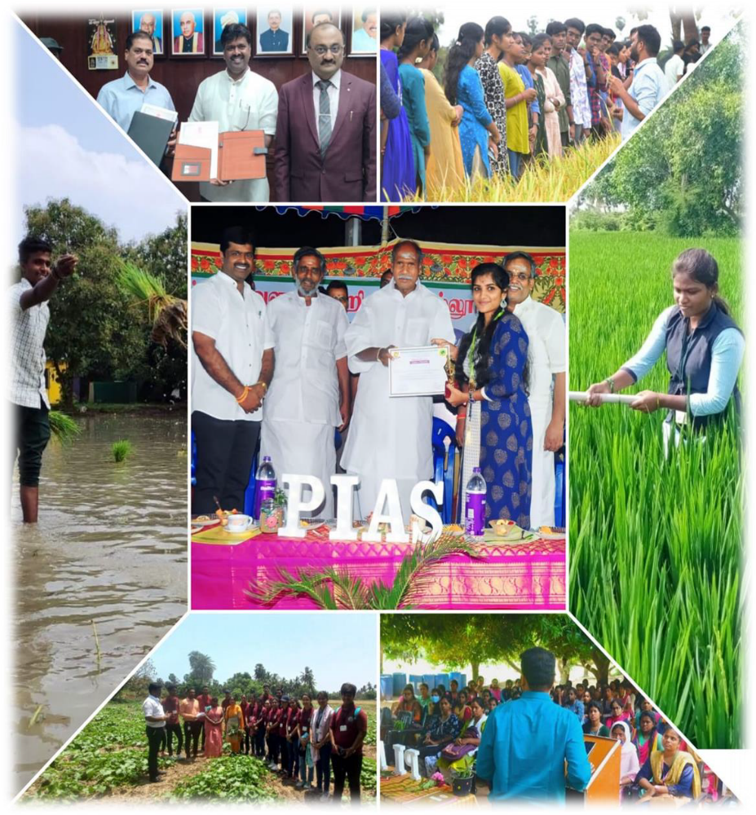
ANNUAL REPORT
2023-2024
From the Chairman’s Desk – Annual Report 2023–2024
The academic year 2023–2024 was a landmark year in the journey of PIAS. This year, our institute witnessed a surge in innovation, student participation, and partnerships, reflecting our evolving role as a center of excellence in practice-based agricultural education.
We introduced value-added certificate modules in mushroom cultivation, terrace gardening, and apiculture, with overwhelming response from students and local communities. Our extension work through CEAD reached farmers across Puducherry and Tamil Nadu, promoting organic inputs and vermiwash trials.
Another milestone was the strategic collaboration with institutions such as NRC Banana, TNAU, and Pondicherry University, strengthening our foundation for future research and B.Sc. programme expansion.
We are proud to have supported our students in securing internships and placements with reputed agri-business firms. Our faculty also undertook key projects in soil biogenic enrichment and natural farming demonstrations.
As we move into the next academic year, we remain dedicated to offering education that not only imparts knowledge but also nurtures sustainability, entrepreneurship, and ethical farming values.
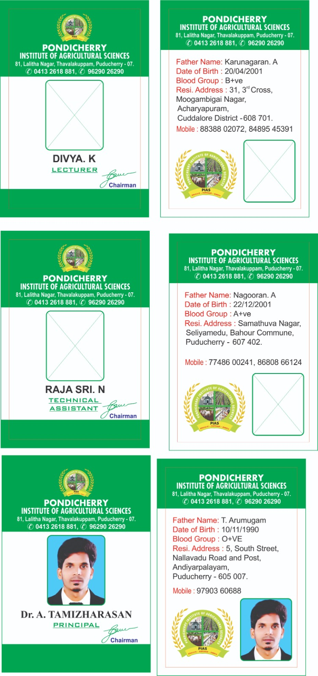
Mr. C. Ganeche
Chairman, PIAS

TABLE OF CONTENTS

- Introduction………………………………………………………………………… | 4
- Vision and Mission………………………………..………………………………... | 6
- Governance & Committees………………………………………………………… | 8
- Academic Programmes……………………………………....................................... | 13
- Curricular & Co-curricular Activities………………………………………………. | 17
- Research Achievements…………………………………………………………….. | 25
- Extension and Outreach Initiatives…………………………………………………. | 28
- Institutional Developments…………………………………………………………. | 32
- Collaborations and Industry Interface ……………………………………………... | 37
- Student Development Programmes………………………………………………… | 41
- Infrastructure Enhancements……………………………………………………….. | 44
- Way Forward……………………………………………………………………….. | 46

1. Introduction

1.1. Institutional Overview
The Pondicherry Institute of Agricultural Sciences (PIAS), established in 2017, stands as a pioneering institution in Puducherry, dedicated exclusively to offering Diploma programmes in Agriculture and Horticulture. With a steadfast commitment to advancing agricultural education, PIAS holds the distinction of being the first and only institute in the Union Territory to provide such diploma-level training. Since its inception, PIAS has evolved into a centre of academic excellence, catering to the educational and vocational aspirations of rural and semi-urban youth, particularly from Puducherry and neighbouring states. Strategically situated between the Pondicherry–Cuddalore state highway corridor, PIAS occupies a sprawling two-acre eco-conscious campus equipped with modern classrooms, fully functional laboratories, experimental farms, greenhouses, and a terrace garden. The institute’s central location and well-planned infrastructure ensure accessibility and optimal conditions for both classroom-based and hands-on field learning.
"PIAS operates under the visionary leadership of its Founder and Chairman, Mr. C. Ganache, an accomplished agricultural professional holding a Master’s degree in Agriculture and a Ph.D. in Ecology and Environmental Sciences from Pondicherry University, Puducherry." His commitment to sustainable development is deeply rooted in his long-standing association with the Centre for Environment and Agricultural Development (CEAD)—a platform through which he has led various green and community-based agricultural initiatives across the Union Territory of Puducherry for over two decades. Mr. Ganache’s holistic approach to education and rural empowerment has significantly shaped the ethos and mission of PIAS. Affiliated with Annamalai University, one of India’s oldest and most respected institutions, PIAS benefits from a strong academic partnership. It has also been re-accredited with an ‘A+’ grade by the National Assessment and Accreditation Council (NAAC), reflecting its commitment to maintaining high standards in curriculum delivery, infrastructure, governance, and institutional values. This recognition highlights PIAS as a model institution known for its distinctive academic environment, value-driven pedagogy, and social responsibility.
The academic framework at PIAS is designed to provide a multidimensional learning experience. Students are exposed not only to theoretical knowledge but also to hands-on experiential learning through regular fieldwork, farm-based experiments, study tours, and industry interactions. The curriculum is enriched with certificate and value-added courses in areas such as mushroom cultivation, terrace gardening, herbal medicine, vermicomposting, and organic farming techniques. These initiatives equip students with practical skills aligned with current agricultural demands and green technologies. A core tenet of PIAS is its value-based education system, which emphasizes discipline, punctuality, and social responsibility. The institute maintains a supportive and nurturing environment that fosters emotional intelligence, leadership, and ethical behavior. Through a series of motivational talks, career guidance sessions, leadership development workshops, and personal counselling programs, students are empowered to face personal and professional challenges with confidence and clarity. Faculty members at PIAS are not just academic instructors but also mentors and guides who invest in the holistic development of every student.
PIAS promotes an inclusive and student-centric learning environment, encouraging participation in national and regional seminars, debates, workshops, and competitions. The students of PIAS have consistently earned accolades in intercollegiate events, demonstrating their readiness for future leadership roles in agriculture and allied sectors. Moreover, PIAS’s commitment to environmental sustainability is evident in its campus practices. From the establishment of herbal and Nakshatra gardens to azolla ponds, terrace gardens, and the plantation of traditional and high-value crops, the institute actively engages students in ecological farming models. These green practices not only enhance the biodiversity of the campus but also instil in students the principles of ecological stewardship and sustainable agriculture.
In conclusion, the Pondicherry Institute of Agricultural Sciences is more than just an educational institution; it is a transformative platform for young minds aspiring to make a meaningful impact in the fields of agriculture and environmental sustainability. Through a combination of academic rigor, practical training, value-based learning, and community engagement, PIAS continues to shape socially responsible, technically skilled, and environmentally conscious agricultural professionals.
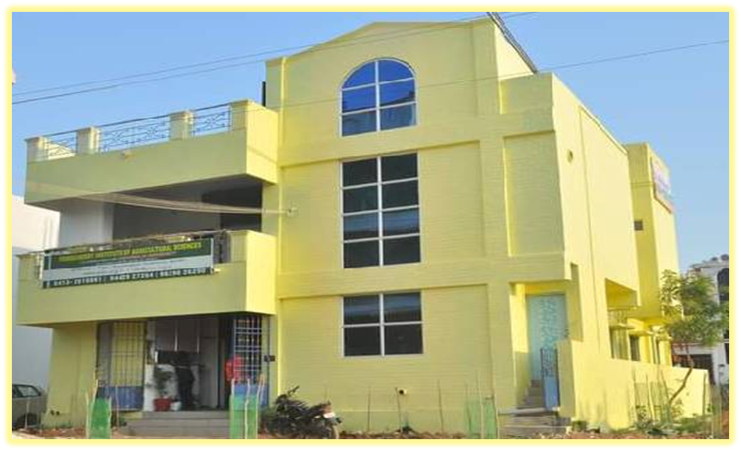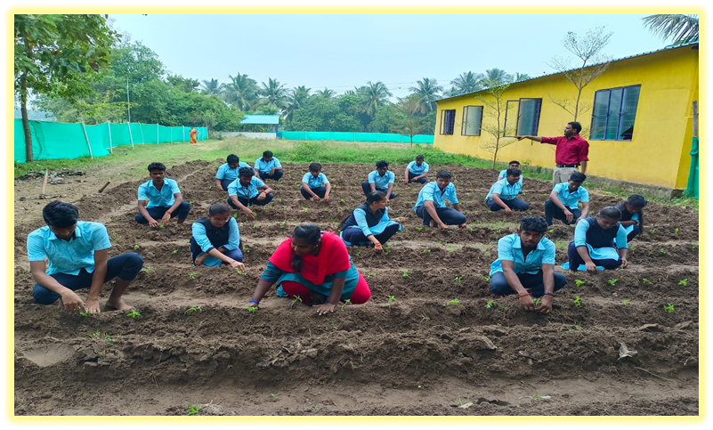
PIAS Campus & Farm

2. Vision and Mission
The Pondicherry Institute of Agricultural Sciences (PIAS) aspires to be a leading institution in agricultural education, research, and rural development. Our vision is to foster a vibrant learning ecosystem rooted in academic excellence, innovation, sustainability, and social responsibility. PIAS aims to nurture globally competent, environmentally conscious, and socially committed professionals who will lead the transformation of rural communities and tackle contemporary challenges such as food security, climate change, and ecological sustainability.
PIAS is dedicated to delivering transformative agricultural education that blends traditional wisdom with modern science and innovation. Our mission is aligned with India’s national priorities including Doubling Farmers' Income, Sustainable Development Goals (SDGs), and Climate-Smart Agriculture.

We are committed to:
- Providing practical and technology-driven education that integrates field-based learning with theoretical excellence.
- Developing multidisciplinary agricultural leaders equipped with global outlooks, entrepreneurial skills, and a strong scientific foundation.
- Instilling values such as truth, fairness, tolerance, cooperation, and environmental stewardship in every learner.
- Collaborating with rural communities, farmers, and NGOs to share knowledge, strengthen capacities, and promote inclusive agricultural development.
- Enhancing life skills, communication, and critical thinking, enabling students to succeed in careers, lead meaningful lives, and contribute to society at large.
Our mission is lived every day—through our classrooms, demonstration plots, field visits, community outreach, and research initiatives that collectively drive positive impact in agriculture.
The PIAS Insignia symbolizes the institute’s core motto:  “Educate, Empower, and Enrich”  It represents the values and aspirations of PIAS through the following key elements: | 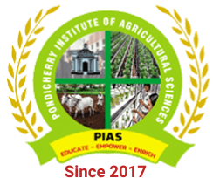
- Pondicherry Secretariat Emblem
Denotes our connection to the heritage and governance of the Union Territory of Puducherry, reflecting institutional pride and public service commitment.

- The Plant
Stands for agriculture, growth, and sustainability, symbolizing our academic focus on crop science and ecological farming.

- The Students
Represent the future of agriculture. Their presence in the emblem affirms our commitment to student-cantered learning and leadership development.

- The Cow
Symbolizes the allied agricultural sectors—particularly animal husbandry—which are essential for income diversification and integrated farming systems.
Together, these components reflect PIAS’s identity as a progressive, inclusive, and mission-driven institution, committed to shaping a greener, more resilient agricultural future.

3. Governance & Committees
The effective functioning of the Pondicherry Institute of Agricultural Sciences (PIAS) is supported by a structured governance framework involving a range of academic, administrative, and student welfare committees. These committees ensure transparency, quality, institutional development, and student-centric progress. Each committee is guided by dedicated staff members and works collaboratively to uphold academic excellence, research innovation, and campus safety.

3.1. Academic Governance Committees

3.1.1. Academic Planning & Curriculum Committee (APCC)
To review and enhance the academic curriculum in alignment with evolving trends in agricultural education and regulatory standards.
Responsibilities:
- Designing and updating course syllabus
- Scheduling academic calendars and timetables
- Introducing and monitoring value-added courses
- Assessing course outcomes and student feedback

In-charge:
- Convener: Dr. M. Subasri
- Members: Dr. A. Thamizharasan, Mr. P. Manikandan, Ms. K. Jayasavitha, Ms. M. Monika

3.1.2. Board of Studies (BoS)
To approve academic programme structures and ensure curriculum relevance and quality.
Responsibilities:
- Finalizing course content and structure
- Ensuring compliance with Annamalai University guidelines
- Recommending instructional materials

In-charge:
- Chairperson: Dr. C. Ganache
- Faculty Representatives: Dr. A. Thamizharasan, Mr. P. Manikandan, Ms. R.Vinitha
- External Experts: Dr. R. Anandan, Faculty of Agriculture, Annamalai University, Annamalai Nagar. Cuddalore, Tamil Nadu, - 608002.

3.2. Administrative & Strategic Committees

3.2.1. Governing Body
To provide policy direction, strategic planning, and administrative oversight.
Responsibilities:
- Reviewing institutional development plans
- Approving budgets and infrastructure proposals
- Facilitating partnerships and MoUs

Chairperson: Mr. C. Ganeche
Members: Principal, External Academic Expert, Parent Representative

3.2.2. Institutional Development Committee
To oversee campus development, digital initiatives, and sustainability projects.
Responsibilities:
- Infrastructure expansion and maintenance
- Green campus projects (e.g., Herbal Garden, Nakshatra Vanam)
- Aesthetic and functional campus planning

In-charge:
- Coordinator: Dr. M. Subasri
- Members: Mr. P. Manikandan, Mrs. B. Sathya, Farm Manager and Technical Assistant

3.3. Examination and Evaluation Committees

3.3.1. Examination Committee
To ensure smooth conduct of examinations in compliance with university regulations.
Responsibilities:
- Preparing schedules and managing logistics
- Securing question papers and coordinating with evaluators
- Conducting both internal and external assessments

In-charge:
- Chief Superintendent: Dr. M. Subasri
- Coordinators: Mr. P. Manikandan, Ms. K. Jayasavitha, Ms. M. Monika

3.3.2. Results Review & Moderation Committee
To ensure the accuracy, fairness, and timely release of examination results.
Responsibilities:
- Reviewing and finalizing marks
- Handling discrepancies and grievances
- Publishing provisional and final results

In-charge:
- Head of Evaluation: Dr. M. Subasri and Dr. A. Thamizharasan
- Members: Course Coordinators and Department Representatives

3.4. Student Support and Welfare Committees

3.4.1. Anti-Ragging Committee
To ensure a safe, inclusive, and disciplined campus environment.
Responsibilities:
- Monitoring student behavior
- Conducting awareness and counselling programs
- Enforcing UGC anti-ragging guidelines

In-charge:
- Chairperson: Dr. M. Subasri
- Student Welfare Officer: Mrs. B. Sathya
- Members: Class Mentors, Parent Representative

3.4.2. Student Grievance Redressal Committee
To address and resolve student concerns in an effective and impartial manner.
Responsibilities:
- Receiving and investigating complaints
- Ensuring timely redressal
- Promoting student welfare and satisfaction

In-charge:
- Convenor: Mr. P. Manikandan
- Members: Ms. K. Jayasavitha, Ms. M. Monika

3.5. Skill Development and Career Services Committees

3.5.1. Placement & Career Guidance Cell
To prepare students for employment and link them with potential employers.
Responsibilities:
- Organizing campus interviews and industry visits
- Conducting career orientation and training
- Collaborating with agriculture-related firms and nurseries

In-charge:
- Coordinator: Mr. D. Sathyaraj
- Training Officers: Mrs. B. Sathya, Mr. Karl Marks

3.5.2. Internship and Industrial Training Committee
To coordinate practical training and field exposure for students.
Responsibilities:
- Arranging internships with agri-industries and research centres
- Supervising student performance during training
- Gathering feedback from host institutions

In-charge:
- Convener: Mr. P. Manikandan
- Field Coordinators: Mr. D. Sathyaraj and Mr. Karl Marks

3.6. Co-curricular and Extension Committees

3.6.1. Cultural Committee
To promote student engagement through cultural and traditional events.
Responsibilities:
- Organizing festivals, annual day functions, and competitions
- Supporting participation in inter-collegiate cultural events

In-charge:
- Convenor: Ms. K. Jayasavitha
- Support Staff: Mr. D. Sathyaraj and Mr. Karl Marks and Ms. M. Monika

3.6.2. Extension and Community Outreach Committee
To build community relationships and provide agricultural training to stakeholders.
Responsibilities:
- Organizing farmer interaction programs
- Conducting school visits and demonstrations
- Promoting agro-tourism and training
In-charge:
- Coordinator: Dr. A. Thamizharasan
- Outreach Team: Mr. Karl Marks and Ms. M. Monika

3.7. Research and Innovation Committees

3.7.1. Research Coordination Committee
To promote institutional research, innovation, and academic publication.
Responsibilities:
- Supporting research in sustainable agriculture
- Coordinating MoUs and collaborative projects
- Facilitating faculty and student research activities

In-charge:
- Chairperson: Dr. M. Subasri
- Faculty Researchers: Dr. A. Thamizharasan and Mr. D. Sathyaraj
- Research Assistants: Mr. Manikandan

4. Academic Programmes
The Pondicherry Institute of Agricultural Sciences (PIAS) is committed to offering high-quality, practical, and industry-relevant education in the disciplines of Agriculture and Horticulture. The academic programmes are designed to provide students with a solid theoretical foundation, hands-on training, and an ecologically responsible mindset. These programmes align with national agricultural priorities, sustainable farming practices, and the developmental needs of rural communities.

4.1. Diploma in Agriculture
This two-year full-time programme imparts essential knowledge in soil science, crop production, agronomy, organic farming, farm machinery, and agribusiness management. The curriculum is developed in accordance with Annamalai University’s academic guidelines, ensuring credibility and academic rigor.

4.2. Diploma in Horticulture
Focused on fruit and vegetable cultivation, nursery techniques, floriculture, landscaping, and post-harvest technology, this two-year diploma addresses the rising demand for skilled horticultural professionals and promotes entrepreneurship in horticulture-based industries.

4.3. Academic Affiliation
PIAS is affiliated with Annamalai University, a distinguished institution in agricultural education. This affiliation ensures that our academic content, evaluation procedures, and degree recognition meet the quality standards set by the University Grants Commission (UGC) and the National Assessment and Accreditation Council (NAAC).

4.4. Curriculum Structure
Both diploma programmes are structured over four semesters and include:
- Core theory courses
- Practical and laboratory components
- Fieldwork and project-based learning
- Value-added certification courses in:
  - Mushroom Production
  - Organic Farming
  - Vermicomposting
  - Terrace and Herbal Gardening
Assessment includes continuous internal evaluation (CIA), mid-semester tests, and final theory/practical examinations. The curriculum is outcome-oriented and prepares students for employment or higher studies.

4.5. Student Intake and Diversity
For the academic year 2023–2024, PIAS has an approved intake of 28 students:
- Diploma in Agriculture – 19 students
- Diploma in Horticulture – 9 students
Admissions are based on 12th standard marks, with priority given to students from rural and agricultural backgrounds. The institute embraces regional diversity, attracting students from Puducherry, Tamil Nadu, and neighboring states.

4.6. Innovative Pedagogy
PIAS integrates modern and practical teaching methods to enhance learning:
- Field-Based Learning: Daily farm exposure for real-time understanding of plant and soil sciences.
- ICT-Enabled Classrooms: Use of digital boards, audiovisuals, and e-learning tools.
- Exposure Visits: Organized study tours to research stations, agri-universities, and farms.
- Skill Training Modules: Mandatory training in vermicomposting, nursery techniques, and sustainable farming.
- Workshops & Self-Development Sessions: Including the “Who Am I?” programme and leadership training to promote holistic growth.

4.7. Outcome-Based Learning
Student performance is evaluated through the OGPA system (Out of 10). Assessments include practical skills, project work, attendance, and participation in extension activities. The programmes aim to produce technically competent, career-ready, and socially responsible graduates.

4.8. Academic Ecosystem

Academic Almanac – 2023–2024

S. No. | Event | Third & First Semesters
1 | Semester Commencement | 23.03.2023
2 | First-Year Induction | 25.03.2023
3 | Class Commencement | 27.03.2023
4 | Mid-Semester Examination | 16.06.2023
5 | Practical Examination | 03.08.2023
6 | Theory Examination | 16.08.2023

S. No. | Event | Fourth, Second & First Semesters
1 | Semester Commencement | 04.09.2023
2 | Class Commencement | 06.09.2023
3 | Mid-Semester Examination | 01.10.2023
4 | Theory Examination | 07.01.2024
5 | Practical Examination | 28.01.2024

4.9. Institutional Profile
- Registered Name: Pondicherry Institute of Agricultural Sciences (PIAS)
- Established: 2017
- Type: Co-educational
- Affiliation: Annamalai University
- Student Identity: PIASians
- Current Strength: 28 students (26 boys, 2 girls)
PIAS is now recognized as a leading institution for diploma-level agricultural education in Puducherry. Its commitment to academic excellence, sustainable farming, and community development continues to empower aspiring agriculturists.

4.10. Faculty Profile
S. No. | Faculty Name | Designation
1 | Dr. M. Subasri | Principal
2 | Dr. A. Thamizharasan | Voice Principal
3 | Ms. M. Monika | Assistant Professor
4 | Ms. K. Jayasavitha | Assistant Professor
5 | Mr. P. Manikandan | Lecturer
6 | Mr. D. Sathyaraj | Guest Lecturer
7 | Ms. R. Vinitha | Lecturer
8 | Mr. Karl Marks | Lecturer
9 | Mrs. B. Sathya | Admin
10 | Mrs. K. Jayalakshmi | Project Officer

4.11. Institutional Committees
- Academic Committee
- Admission Committee
- Career Development Committee
- Examination Committee
- Anti-Ragging Committee
- Sports Committee
These committees play a crucial role in maintaining academic quality, discipline, student welfare, and extracurricular engagement.

4.12. Curricular Development Highlights
PIAS offers:
- Diploma in Agriculture
- Diploma in Horticulture
With additional value-added certifications in:
- Mushroom Production
- Terrace and Herbal Gardening
- Vermicomposting
- Organic & Sustainable Agriculture
The curriculum is practical in orientation and includes farm-based projects, skill training, and field exposure, ensuring employability and real-world application.

4.13. Teaching, Learning & Evaluation
- Admission Criteria: 12th-grade performance, with preference for students from farming backgrounds.
- Diversity: Students come from a variety of socio-economic and regional backgrounds.
- Pedagogy: Emphasis on experiential learning, hands-on training, and tech-based instruction.
- Evaluation: Semester-based system using OGPA (out of 10) for transparent and consistent assessment.

4.14. Placement & Career Development
The Placement Cell conducts:
- Pre-placement training
- Industry interface sessions
- Campus interviews

4.15. Placement Highlights (2023–2024)
- UCAL Drone Manufacturing, Chennai
- Shanthi Clonal Nursery, Vegakollai
Several students also participated in internships and hands-on training programmes, enhancing their professional readiness.

4.16. Governance and Leadership
Under the guidance of Chairman Mr. C. Ganeche, PIAS emphasizes strategic growth, academic innovation, and community outreach. Monthly leadership review meetings are held to assess institutional progress and ensure excellence in all areas—from academics to infrastructure development and student success.

5. Curricular & Co-curricular Activities
At the Pondicherry Institute of Agricultural Sciences (PIAS), academic learning is deeply enriched through a wide range of curricular and co-curricular activities that emphasize hands-on experience, cultural identity, student engagement, and environmental consciousness. These activities are integrated into the academic calendar to enhance student learning, skill development, and social interaction.

5.1 Curricular Enrichment Activities
To supplement classroom-based teaching, PIAS organizes several field-based and experiential learning programmes designed to bridge theoretical knowledge with real-world agricultural practices:

5.1.1. Study Tours and Educational Visits
Students were taken on structured study tours to reputed institutions such as:
- Tapioca and Castor Research Station, Yethapur
- Department of Sericulture, Anaiyamedu
- Tamil Nadu Agricultural University, Coimbatore
- National Research Centre for Banana (NRCB), Trichy
- Horticultural Research Station (HRS), Kodaikanal
- HC&RI, Periyakulam
- Grapes Research Station, Theni
- biofertilizer lab, Cuddalore
- Uzhavar Santhi, Cuddalore
- SRS, Cuddalore
These visits provided students exposure to advanced crop research, farming models, and post-harvest technologies.
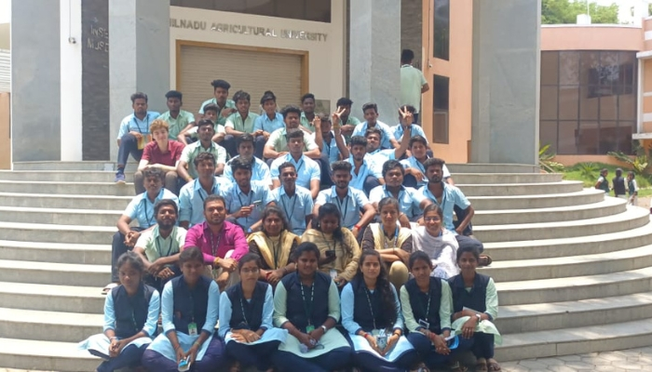
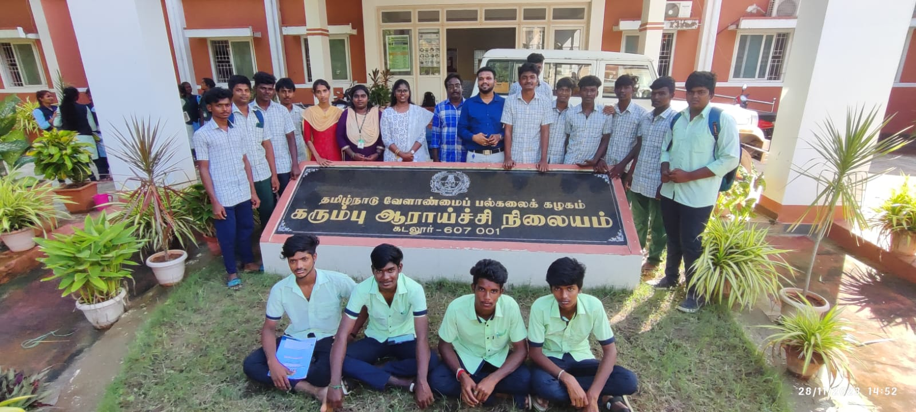

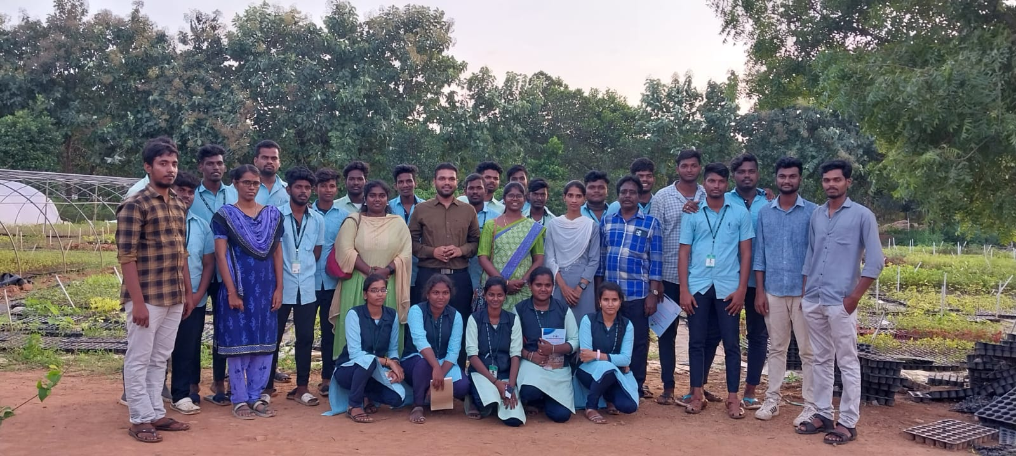

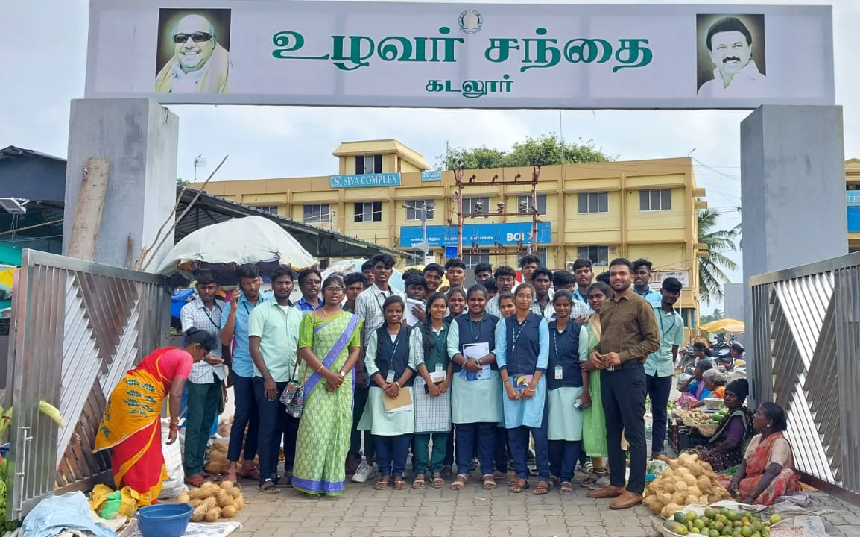
Study tour at research stations

5.1.2. Terrace Gardening Project
As part of their practical coursework, students actively participated in the establishment of a terrace garden at the campus. This initiative not only promoted self-sufficiency in vegetable cultivation but also emphasized urban agriculture and sustainability.
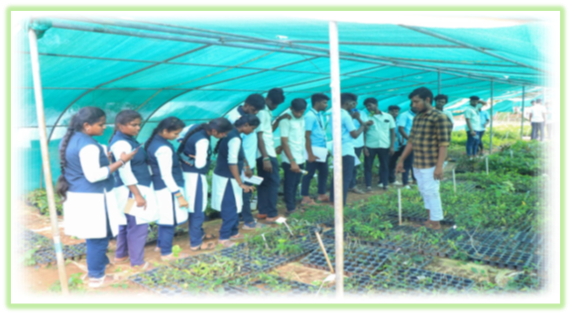
Students working in terrace gardens

5.1.3. Herbal Gardening
As part of their practical training, students were actively involved in the establishment and maintenance of a dedicated herbal garden on the PIAS campus. This hands-on initiative aimed to enhance their knowledge of medicinal and aromatic plants, including species such as Tulsi, Aloe Vera, Vetiver, and Ashwagandha.
Through activities such as bed preparation, seedling transplantation, organic input application, and plant labeling, students gained real-time experience in plant identification, propagation techniques, and therapeutic value assessment. The herbal garden also served as a live demonstration plot for sustainable health-linked agriculture and promoted awareness about the traditional role of plants in natural healing.
This initiative reinforced concepts of biodiversity conservation, eco-farming, and rural entrepreneurship, aligning with the institute’s broader goals of integrating practical skill development with community-oriented learning.
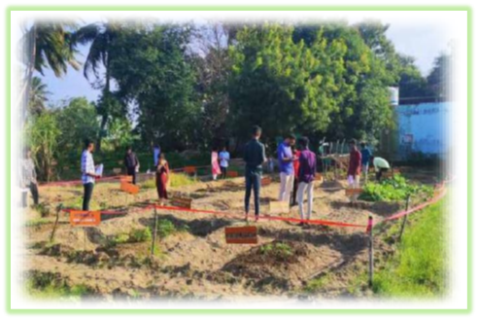
Students working in herbal gardens

5.2. Co-curricular Activities
At PIAS, co-curricular activities are carefully curated to promote cultural expression, community awareness, and leadership qualities among students.

5.2.1. World Soil Day 2024 Celebration
On December 9, 2024, PIAS commemorated World Soil Day with a series of engaging educational activities aimed at promoting awareness on soil conservation, fertility enhancement, and sustainable land use practices. The central highlight of the event was a quiz competition, which saw enthusiastic participation from both PIAS students and visiting school and college students. The competition encouraged critical thinking and fostered a spirit of healthy academic rivalry and collaborative learning.
In addition to the quiz, the celebration featured:
- Awareness Programmes: Expert talks and interactive sessions on the importance of soil in natural farming, climate resilience, and food security.
- Audio-Visual Presentations: Informative videos and documentaries showcased real-world soil challenges and eco-friendly solutions.
- Poster and Model Exhibits: Students creatively displayed posters and working models on key themes such as soil biodiversity, erosion control techniques, vermicomposting, and organic input application.
The event successfully cultivated a deeper understanding of soil as a living resource and inspired students to take an active role in promoting sustainable agricultural practices and environmental stewardship.
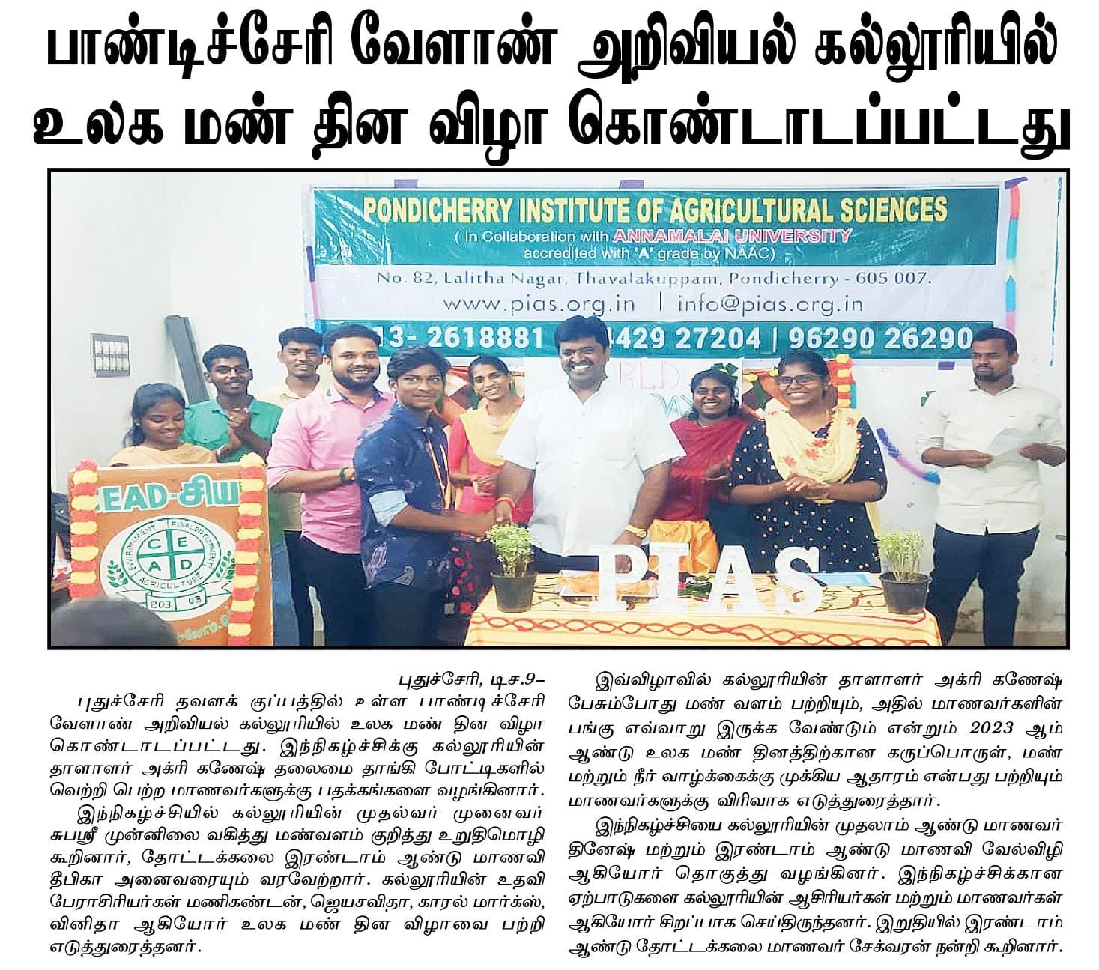

5.2.2. PM Food Preservation Meeting
On December 17, 2023, PIAS hosted a focused meeting on Food Preservation and Value Addition, conducted under the Prime Minister's Micro Food Processing Enterprises (PMFME) scheme. The session aimed to create awareness among students, local entrepreneurs, and rural youth about modern preservation techniques, small-scale food processing, and value chain development in agriculture.
Key highlights of the meeting included:
- An introduction to the PMFME scheme, including financial assistance, incubation support, and FSSAI compliance requirements.
- Demonstrations on preserving fruits, vegetables, and grains through dehydration, pickling, and packaging methods.
- Discussions on marketing strategies, labeling, and shelf-life extension to improve income through value-added agri-products.
The meeting served as a valuable platform to promote entrepreneurship opportunities in food processing, especially for women, SHG members, and diploma students. It also aligned with PIAS’s goal to integrate agri-business training into academic and extension activities.

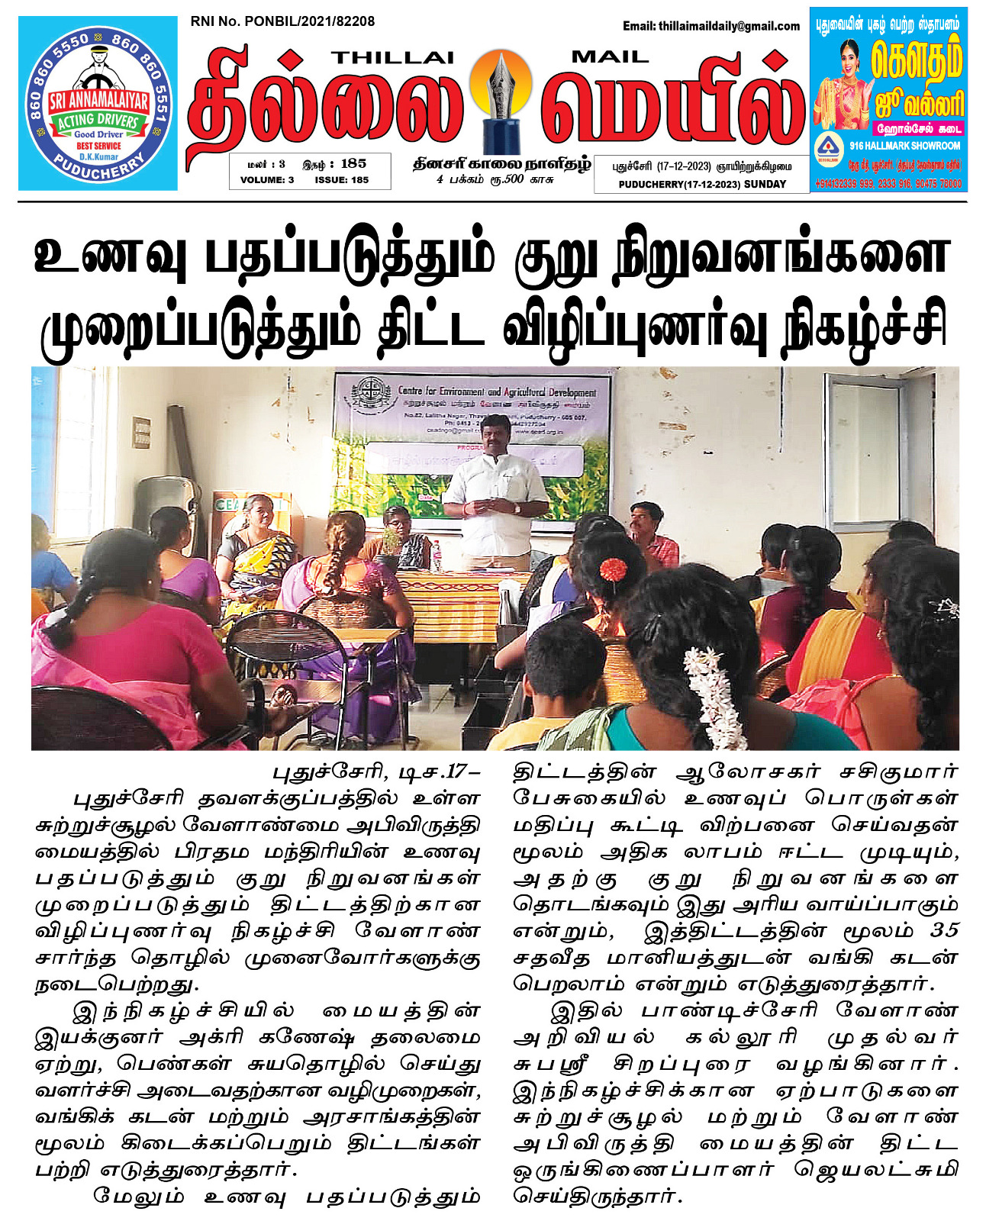

Students and entrepreneurs attending PMFME awareness session on food preservation

5.2.3. Pongal Vizha Celebration
The spirit of Tamil culture and agricultural heritage came alive on January 18, 2024, as PIAS celebrated Pongal Vizha, the traditional harvest festival of Tamil Nadu. The campus was adorned with festive decorations, colorful rangoli designs, sugarcane displays, and traditional earthen pots, creating a vibrant and immersive cultural atmosphere.
The celebration featured a range of engaging activities, including:
- Cultural Performances such as folk songs, dances, and drama depicting the life of farmers.
- Traditional Pongal Preparation, where students took part in cooking the sweet dish using traditional clay pots and firewood, symbolizing gratitude to nature and the harvest.
- Rangoli Art Competitions, showcasing creativity and regional patterns drawn with rice flour and flower petals.
- Folk Games and Activities like uri adithal (pot breaking), tug-of-war, and kabaddi, bringing students and staff together in festive cheer.
Beyond entertainment, the celebration provided an opportunity for students to understand the agricultural significance of Pongal, reinforcing their connection to rural life and traditional farming values. The event successfully promoted cultural awareness, social unity, and respect for indigenous farming customs among the student community.
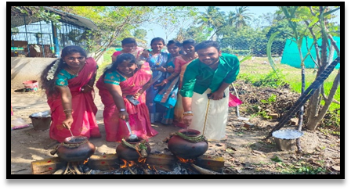
Tamil harvest festival

5.2.4. Coconut Planting at PIAS Farm
As part of the campus greening and agroforestry development initiatives, students and faculty of PIAS participated in a coconut planting programme at the institute’s farm. This activity was aimed at enhancing long-term farm productivity, promoting multi-layer cropping systems, and providing practical experience in perennial crop establishment.
During the session, students learned:
- Proper techniques of pit preparation, spacing, and soil amendment
- Selection of high-yielding coconut varieties suitable for regional climate
- Water management and post-planting care to ensure healthy establishment
The coconut plantation not only serves as a live model for teaching plantation crop management, but also contributes to the eco-restoration and shade creation goals of the campus. This initiative reflects PIAS’s vision of integrating education with sustainable farm development.
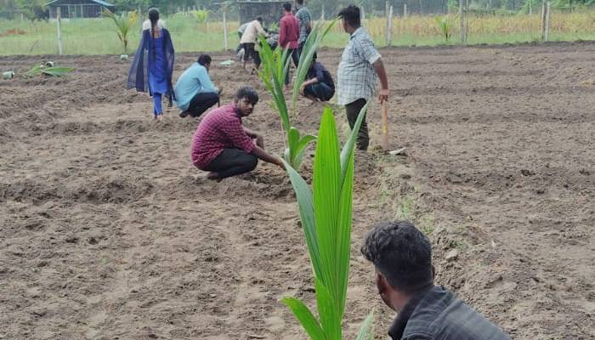
Students participating in coconut planting at the PIAS farm site

5.2.5. Students’ Debate Programme
To enhance critical thinking, communication skills, and awareness of agricultural and environmental issues, PIAS organized a Debate Programme for its diploma students. The event provided a dynamic platform for participants to express their views on current topics related to natural farming, climate change, agri-entrepreneurship, and sustainable rural development.
Key features of the programme included:
- Thought-provoking debate topics such as “Organic vs. Chemical Farming”, “Technology in Traditional Agriculture”, and “Youth in Agri-Startups”
- Participation from both first- and second-year students, judged by faculty members based on clarity, content, and confidence
- Emphasis on fact-based argumentation, public speaking, and respectful counterpoints
The programme encouraged students to develop a balanced perspective, enhance their public speaking abilities, and engage in peer learning. It also highlighted the importance of communication as a vital skill in promoting agricultural awareness and leadership.
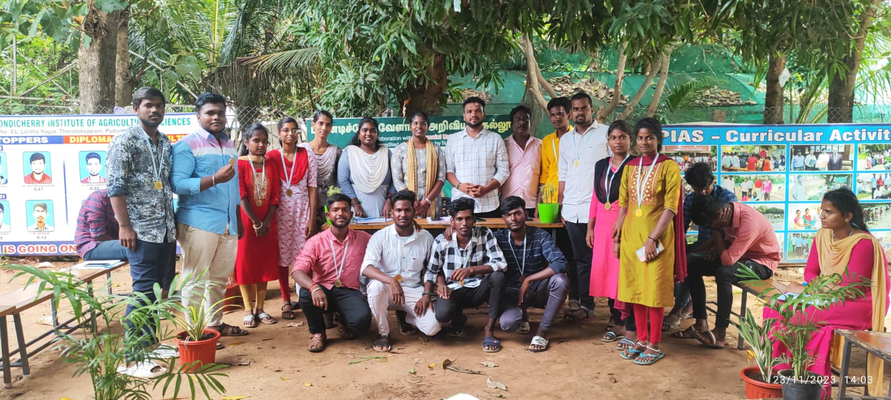
Students participating in the inter-departmental debate on sustainable agriculture

5.2.6. Annual Day Celebration
The Annual Day Celebration at PIAS, held in May 2024, marked the joyful culmination of an eventful academic year. The occasion brought together students, faculty, staff, parents, and invited dignitaries in a vibrant gathering that celebrated academic achievements, cultural talent, and institutional growth.
The programme included:
- Welcome Address and Annual Report Presentation by the Principal, highlighting milestones in research, teaching, and outreach.
- Prize Distribution Ceremony, recognizing students for their excellence in academics, cultural events, sports, and social contributions.
- Cultural Performances, including traditional dances, skits, group songs, and dramatic enactments reflecting rural life and agricultural themes.
- Special Address by the Chairman, Mr. C. Ganeche, who emphasized the importance of skill-based education, sustainability, and future goals of the institute.
The event served as a moment of pride and reflection for the entire PIAS community. It also fostered a sense of unity, motivation, and appreciation for the collective efforts of faculty, students, and support staff throughout the academic year.

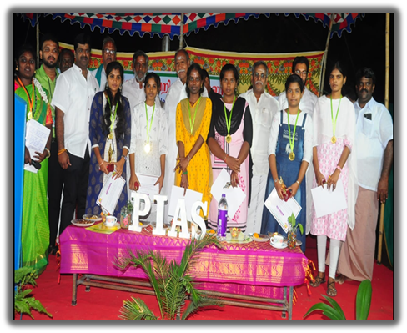
Awards and Recognitions Received by PIAS Diploma Students

6. Research Achievements
The Pondicherry Institute of Agricultural Sciences (PIAS) places strong emphasis on practice-based, eco-sustainable research, focusing on challenges relevant to regional agriculture and national priorities. Our research efforts are led by committed faculty and actively involve student participation through field trials, pilot studies, and laboratory work, encouraging a research-oriented academic environment even at the diploma level.

6.1. Collaborative Research Platforms
Research at PIAS is supported and facilitated through institutional and external collaborations, notably:
- Centre for Environment and Agricultural Development (CEAD) – our in-house partner in sustainable agriculture research and green initiatives.
- Linkages with government departments, local NGOs, and nursery entrepreneurs for field demonstrations, data collection, and dissemination.
- Collaborative projects supported by Centre for Sustainability and Climate Studies, Department of Ecology and Environmental Sciences, Pondicherry University,

6.2. Research Themes and Ongoing Work

6.2.1. Organic Farming with Traditional Paddy Varieties
Faculty and students conducted field-based organic trials using native paddy varieties under organic nutrient management protocols. This project emphasized:
- Zero-chemical input systems
- Use of panchagavya, vermiwash, and botanical extracts
- Assessments of grain yield, disease resistance, and grain quality

6.2.2. Soil Health and Biogenic Soil Applications
PIAS has taken up field evaluations of biogenic soils—enriched with earthworm castings, organic matter, and beneficial microbes—for:
- Improving soil structure and porosity
- Enhancing microbial biomass and nutrient availability
- Promoting carbon sequestration and erosion resistance

6.2.3. Vermicomposting and Vermiwash Production
Multiple pilot-scale vermicomposting units were established on campus using leaf litter, cow dung, and local weeds. Outcomes include:
- Production of nutrient-rich compost
- Extraction and application of vermiwash as a foliar spray
- Biochemical analysis of nutrient profiles (NPK, micronutrients)
- Positive impacts recorded on okra plant growth and flowering

6.2.4. Microgreens Cultivation Trials
A recent initiative includes low-cost microgreens cultivation models, using recycled trays and organic media. Studies focus on:
- Nutritional profiling of species like mustard, fenugreek, and radish
- Growth comparisons under shade nets vs. open sun
- Market potential and consumer awareness

6.2.5. Biocontrol and Pest Management
As part of plant health management, students engaged in testing botanical biopesticides such as:
- Neem oil sprays
- Garlic and chili extract formulations
- Trichoderma and Pseudomonas fluorescens bioinoculants
The studies aimed to:
- Minimize use of synthetic pesticides
- Improve pest suppression in leafy vegetables and legumes

6.2.6. Salinity Tolerance Studies
Faculty-led trials using salinity gradients in controlled plots have begun to evaluate the tolerance capacity of select crop varieties (especially rice and groundnut). Parameters include:
- Germination rate
- Seedling vigor
- Ion accumulation (Na⁺, Cl⁻)

6.2.7. Medicinal Plant Cultivation & Evaluation
Under the Herbal Garden project, trials on medicinal plants such as Tulsi, Ashwagandha, and Aloe vera were conducted, studying:
- Growth response to organic inputs
- Pest resistance
- Market linkage with local ayurvedic outlets

6.2.8. Research Areas and Faculty In-Charge
At PIAS, research is integrated with teaching and field extension to support eco-agricultural practices, student learning, and rural innovation. Faculty members actively engage in field trials, student mini-projects, and collaborations with external institutions such as CEAD, NRCB, and Pondicherry University. Below is a summary of the key research domains and the faculty members coordinating them.

Impact and Student Engagement
These research activities:
- Enhance analytical thinking and technical skills among students
- Prepare learners for higher education and entrepreneurship
- Contribute to sustainable rural development models
- Encourage eco-friendly practices applicable to smallholder farming

S. No. | Research Area | Faculty In-Charge | Brief Description
1 | Organic Farming with Traditional Paddy Varieties | Dr. M. Subasri | Conservation and performance evaluation of indigenous rice under natural inputs
2 | Soil Health and Biogenic Soil Application | Dr. A. Thamizharasan | Soil quality improvement using earthworms, termites, and biogenic amendments
3 | Vermicomposting and Vermiwash Production | Ms. K. Jayasavitha | Trials on leaf litter decomposition and nutrient content of vermiwash
4 | Microgreens Cultivation and Nutrition Trials | Mr. P. Monikandan | Study of microgreens’ growth, harvest cycles, and nutritional profiles
5 | Biocontrol and Natural Pest Management | Dr. A. Thamizharasan | Application of neem-based sprays, Trichoderma, and botanical extracts for pest control
6 | Salinity Tolerance in Crop Plants | Dr. M. Subasri | Field experiments assessing crop response under saline irrigation regimes
7 | Medicinal Plant Cultivation and Evaluation | Ms. M. Monika | Growth study of tulsi, aloe vera, and vetiver with focus on yield and active compounds
8 | Herbal Product Development (Soaps, Oils, Balms) | Ms. K. Jayasavitha | Use of herbal raw materials for preparing eco-friendly value-added products
9 | Terrace Gardening and Urban Horticulture Models | Mr. P. Monikandan | Training and trials on low-space cultivation systems for urban and peri-urban settings

7. Extension and Outreach Initiatives
The Pondicherry Institute of Agricultural Sciences (PIAS) strongly believes that agricultural education must extend beyond the classroom and into the fields and communities where it can have real impact. As part of our commitment to community engagement, rural development, and inclusive learning, PIAS undertakes a variety of extension and outreach initiatives that benefit both the student community and local farmers.
These activities are designed to:
- Facilitate two-way knowledge exchange between students and practicing farmers
- Equip students with communication, technical demonstration, and extension skills
- Promote sustainable agriculture at the grassroots level
- Support government missions related to soil health, organic farming, and climate-smart agriculture

7.1. Farmer Interaction Meetings
PIAS regularly conducts interactive sessions and workshops that bring together farmers, students, faculty, and technical experts to address field-level challenges and share best practices.

Key Highlights:
- A one-day “Farmer-Student Interaction” programme was held on 22.02.2023, focusing on:
  - Soil health management
  - Organic pest control methods
  - Water-saving techniques (drip and mulching)
- Farmers from nearby villages such as Thavalakuppam, Kirumampakkam, and Bahour actively participated.
- Demonstrations on vermicompost production, azolla cultivation, and biopesticide preparation were delivered by PIAS faculty and final-year students.
- Feedback sessions allowed farmers to express their practical constraints, which helped PIAS redesign extension modules for future events.
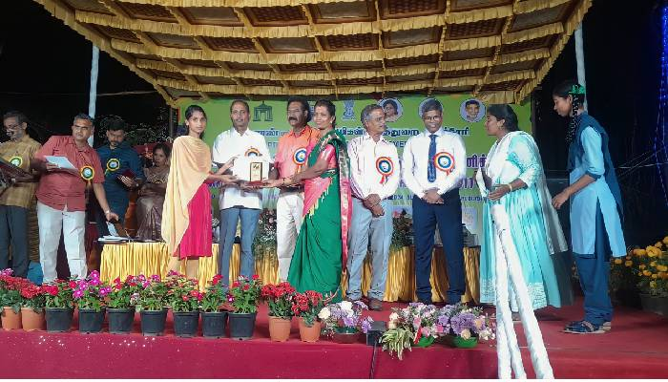

7.2. Exposure Visits and Community Education
To help students and school children better understand the scope of agriculture, PIAS organized one-day exposure visits as part of its agro-education programme.

Activities Conducted:
- One-Day Agro-Tourism Programmes were organized for:
  - Dr. Ambedkar Government Higher Secondary School, Kirumampakkam
  - Achariya School, Puducherry (Montessori I & II students)
During the visits, students explored:
- Vermicomposting pits
- Herbal garden with labeled species
- Terrace gardening systems
- Mushroom production units
- Animal shed and azolla cultivation tanks
Faculty members conducted awareness talks on:
- Importance of organic food
- Conservation of local biodiversity
- Home-scale vegetable gardening
These programmes aim to plant early seeds of interest in agriculture among school children, and also give our students practical experience in demonstration-based teaching.

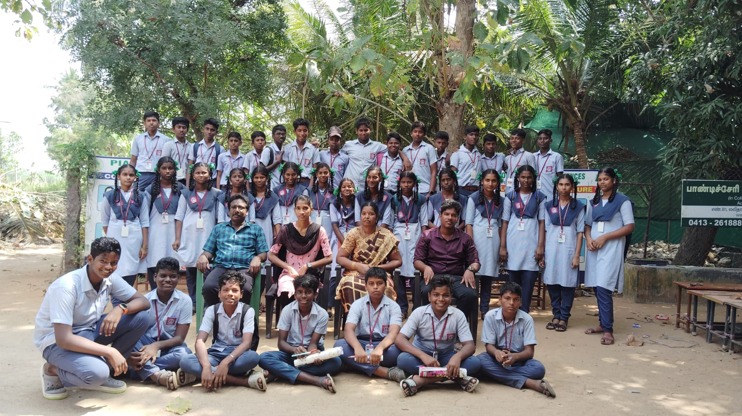

7.3. Green Campus and Demonstration Units
PIAS has developed multiple on-campus live demonstration units to train both students and farmers in cost-effective, replicable agricultural practices.

Key Initiatives:
- Azolla Pond Development:
  - Created by first-year students using recycled cement tanks
  - Demonstrated as a protein-rich livestock feed for cattle and poultry
  - Training modules delivered to visiting farmers and SHGs
- Guava Orchard Establishment:
  - Over 40 guava saplings were planted with the help of students in the orchard zone
  - Topics taught: pruning techniques, pest scouting, irrigation management
- Coconut Plantation:
  - 118 coconut seedlings were planted along the farm perimeter
  - Students learned about spacing, pit preparation, and basal nutrient application
  - This long-term project promotes agroforestry integration on campus
These practices are not only educational models but also contribute to campus sustainability and livelihood-oriented learning.
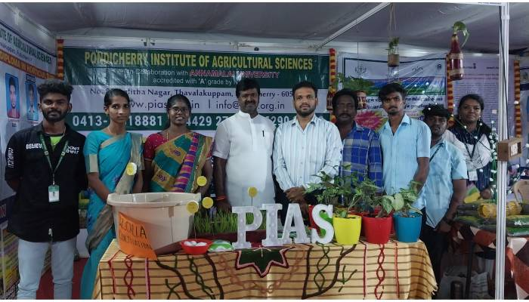

7.4. Thematic Awareness Days and Community Engagement
As part of our extension commitment, PIAS observes internationally significant agricultural and environmental days with active involvement from students and village stakeholders.

World Soil Day 2023:
- Celebrated on 05.12.2023
- Activities included:
  - Student quiz competition
  - Audio-visual awareness sessions
  - Farmer lectures on soil organic matter and erosion prevention
  - Display of student-prepared charts and working models on vermicompost bins, cover cropping, and soil microorganisms

7.5. Additional Awareness Events:
- Medical Camp on World Hypertension Day (05.05.2023)
  - Organized jointly with MGMCRI, benefiting both PIAS staff and local farmers
- Demonstration of Biocontrol Methods
  - Training on the preparation and application of neem extract, cow urine spray, and panchagavya

- “Incense Stick Production” Workshop (26.09.2023)
  - Held for women self-help groups using waste temple flowers
These outreach activities provide relevant, low-cost technologies to farming communities while making students more socially conscious and practically skilled.
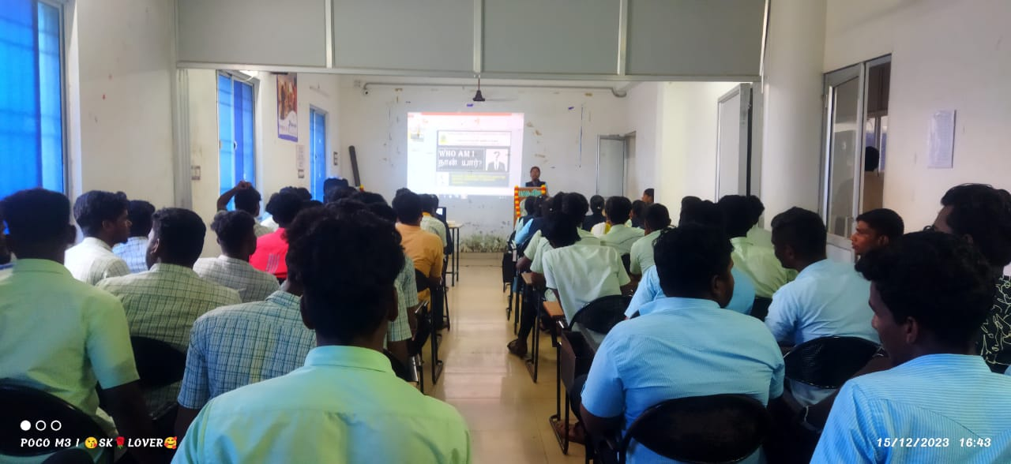

8. Institutional Developments
The Pondicherry Institute of Agricultural Sciences (PIAS) has made significant strides in its physical infrastructure, digital presence, and campus aesthetics during the academic year 2023–2024. These developments are aligned with the institute’s mission to offer a modern, student-friendly, and environmentally enriched learning environment that supports both academic and non-academic growth.
Institutional improvements were planned and executed under the strategic guidance of Chairman Mr. C. Ganeche, with active involvement from faculty members, non-teaching staff, and students. The goal of these initiatives is not only to enhance functionality and visibility but also to foster a campus atmosphere that promotes learning, biodiversity, and community engagement.

8.1. Launch of the Official PIAS Website
In a significant move toward institutional modernization and digital outreach, Pondicherry Institute of Agricultural Sciences (PIAS) proudly launched its official website on December 14, 2023. This marks a pivotal moment in PIAS's journey toward achieving greater transparency, academic visibility, and real-time engagement with stakeholders including students, parents, academic collaborators, and the farming community.
The website, designed with a clean and mobile-responsive interface, serves as a comprehensive digital gateway to all institutional activities, ensuring timely access to key information and enhancing the institute's public presence.

Key Features and Functional Components:
- Dynamic Homepage
  - Showcases PIAS’s vision, mission, and institutional values
  - Real-time announcements, academic updates, and news highlights
- Academic Resources Section
  - Detailed information on Diploma programmes in Agriculture and Horticulture
  - Curriculum structure, semester outlines, and academic calendar
- Faculty Profiles
  - Dedicated profiles of teaching staff with qualifications, research areas, and photos
- Student Activity Archive
  - Galleries and documentation of co-curricular events, outreach activities, and field work
  - Recognition of student achievements, internships, and awards
- Extension and Community Engagement
  - Highlights from farmer training programmes, awareness days, and demonstration plots
- Downloadable Content Repository
  - Admission forms, prospectus, brochures
  - Study materials, value-added course handouts, and lab manuals
  - Timetables and internal assessment schedules
- Communication and Interaction Tools
  - Integrated contact forms and institutional email directory
  - Enquiry submission interface for prospective students and visitors
- Technical Features
  - Mobile-friendly and responsive layout for cross-device compatibility
  - Search-optimized content and secure hosting environment

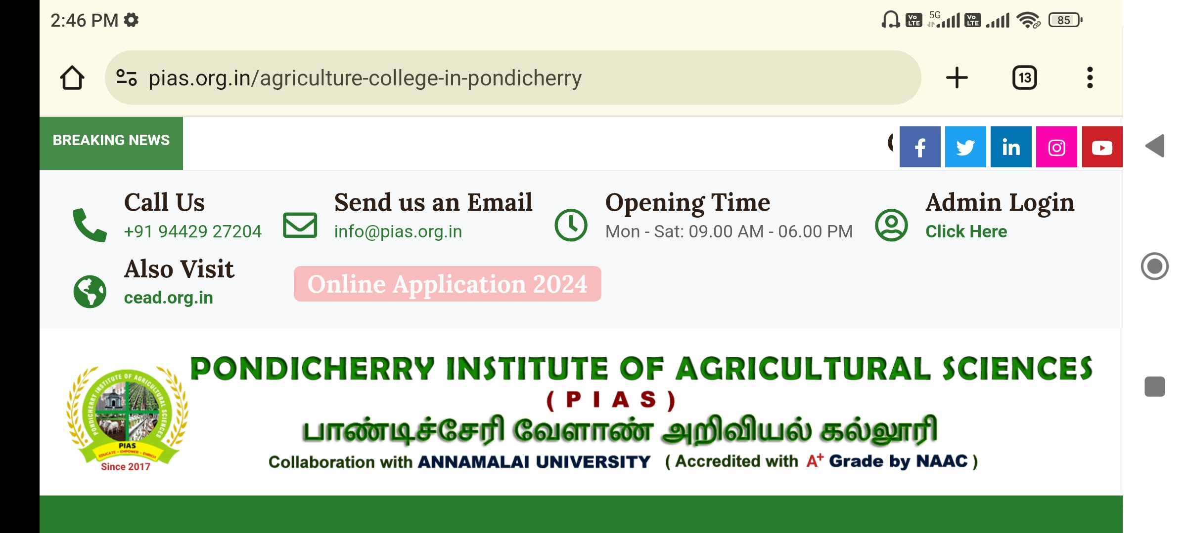
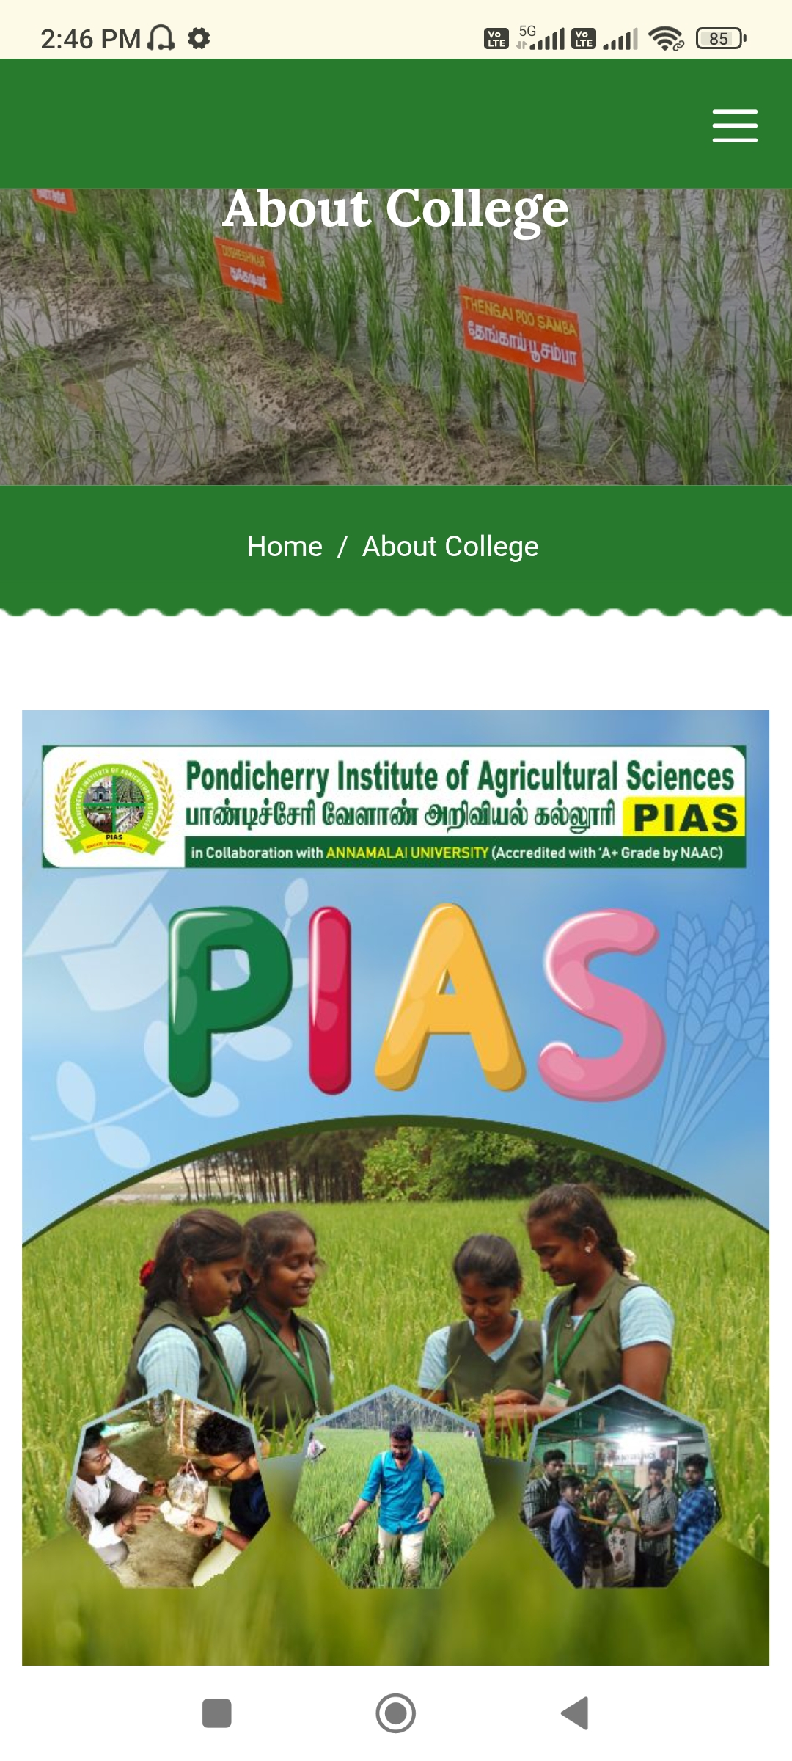
Screenshot of website homepage with navigation bar and quick links.

8.2. Herbal Garden Development with Educational Signage
One of the key highlights in the campus greening initiative has been the establishment of a dedicated Herbal Garden, aimed at promoting the conservation and educational use of medicinal and aromatic plants.

Project Details:
- Inaugurated on 18.10.2023 by Hon. M.P. Selva Ganapathy
- Developed and maintained by students under faculty supervision
- The garden houses over 35 medicinal plant species, including:
  - Ocimum sanctum (Tulsi)
  - Aloe vera
  - Phyllanthus amarus (Keezhanelli)
  - Centella asiatica (Vallarai)

Educational Features:
- Each plant is labeled with botanical name, Tamil name, and medicinal use
- QR-coded signage being developed for scanning and digital learning
- The garden serves as a living laboratory for courses in herbal gardening, environmental studies, and organic plant health management
The Herbal Garden not only enhances biodiversity awareness but also provides students and visiting farmers with insights into ethnobotany, traditional medicine, and commercial herbal products.
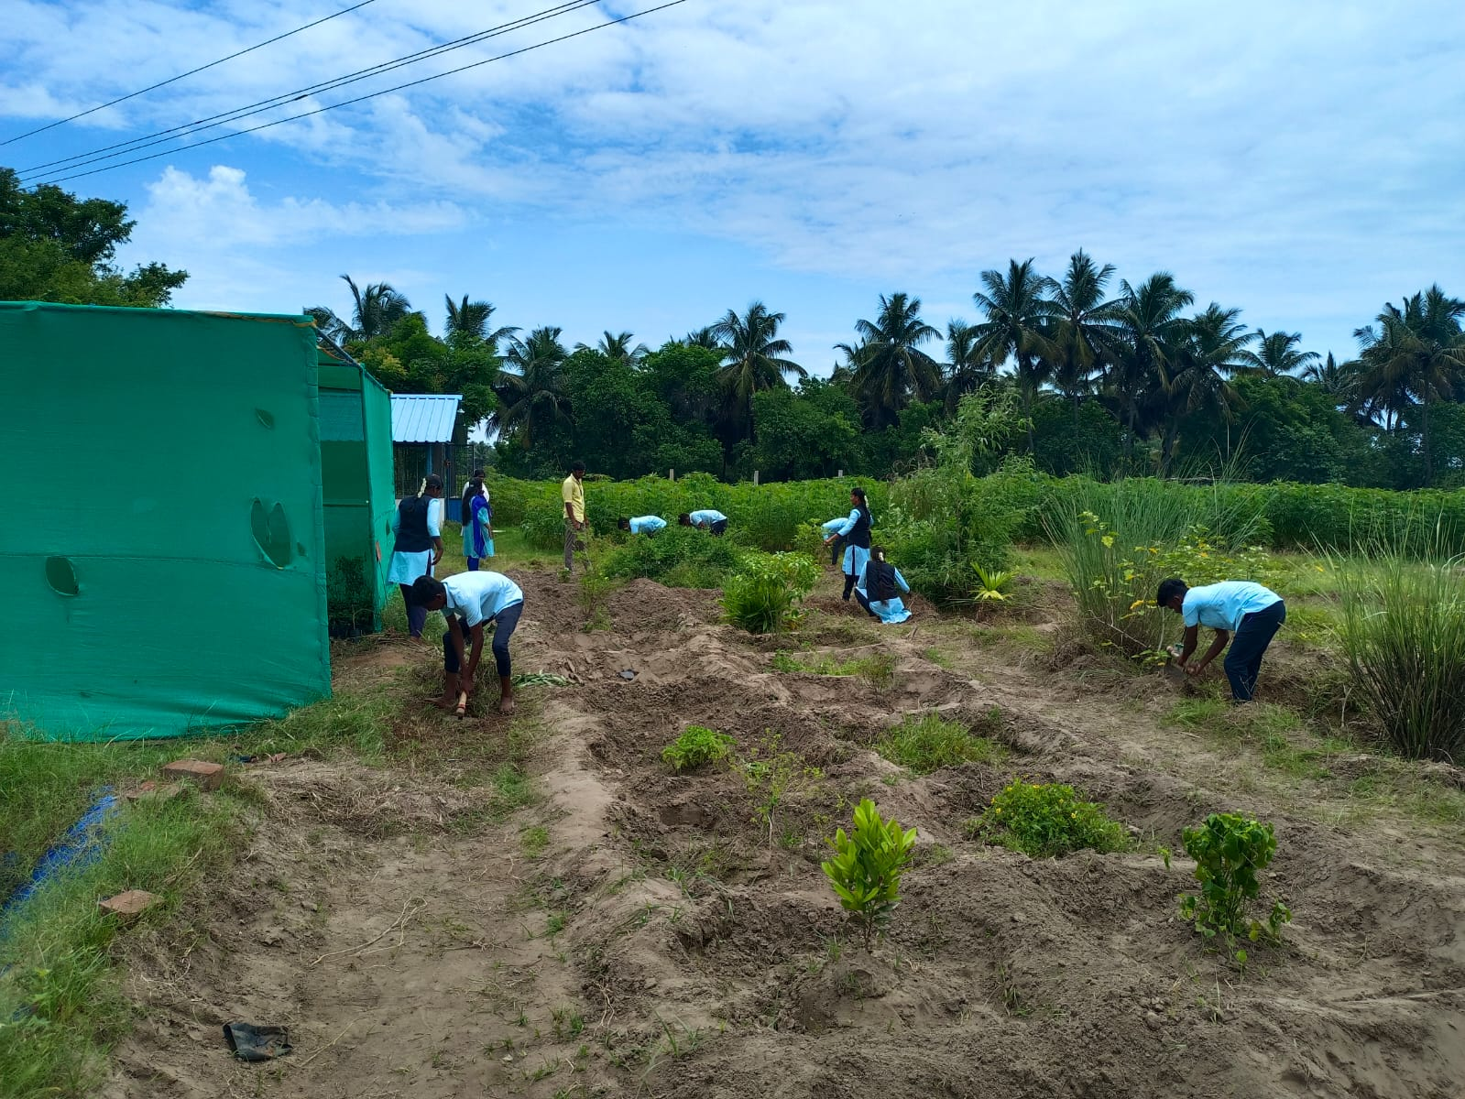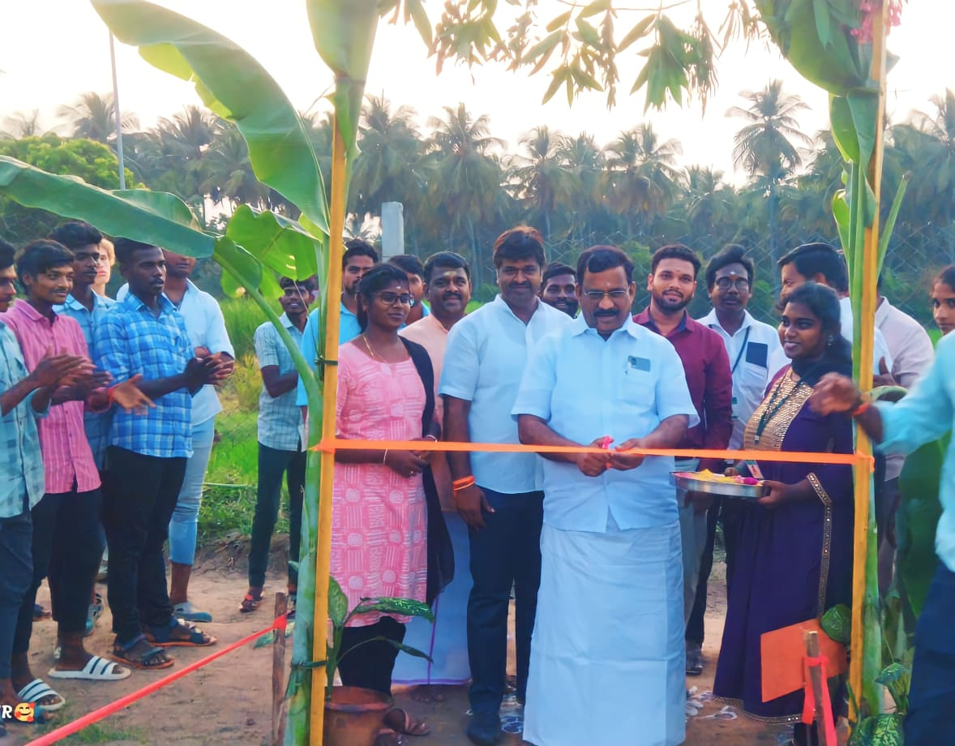
Making and inaugurated of Herbal Garden

8.3. Campus Landscaping and Name Board Placement
As part of PIAS's commitment to developing a green, welcoming, and functional campus environment, several landscaping upgrades and infrastructural improvements were carried out across the institute grounds. These efforts aimed not only to enhance aesthetic value but also to support research, visibility, and ease of campus navigation.

Key Improvements and Additions
- Strategic Landscaping Enhancements
  - Targeted beautification around the mushroom cultivation shed, entrance gate, and mess area
  - Incorporation of decorative flowering plants, shade-providing trees, and ornamental grasses for environmental and visual appeal
  - Installation of seating benches, shaded resting areas, and student discussion zones for practical outdoor learning and relaxation
- Tree Planting and Eco-Greening
  - Expansion of tree cover with planting of coconut, neem, guava, and bamboo along walkways and orchard borders
  - Establishment of native plant blocks for micro-habitat conservation and biodiversity study
  - Student involvement in tree maintenance activities through practical coursework and green volunteer programs
- Installation and Replacement of Name Boards
  - New directional and informational signage installed across key campus locations:
    - Classrooms, labs, herbal garden, vermicomposting zone, nursery plots, and research blocks
  - Multilingual signboards (Tamil and English) to aid both local and outstation visitors
  - Use of weather-resistant materials (metallic frames, laminated boards) for longevity
  - Repaired or replaced damaged signboards due to weathering and wear over the past year, especially near the farm entrance and compost pits

8.3.1. Research Integration into Landscape Zones
With the expansion of green infrastructure, new research areas were also demarcated within landscaped zones for:
- Soil salinity tolerance trials (adjacent to the orchard fence line)
- Medicinal plant experimentation beds (behind the herbal garden signage)
- Biogenic soil application studies (in the vermibed area)
- Agro-forestry layout demo block (near the neem and guava planting stretch)
These functional additions make the landscape not just ornamental but instructional, turning open spaces into living laboratories for student projects and observational studies.

8.3.2. Impact of Institutional Developments

This phase of landscaping and signage development aligns with PIAS's broader vision of building an eco-smart, student-friendly, and research-integrated academic environment. The continued transformation of outdoor areas into purposeful learning zones reflects our belief in learning beyond classrooms—where every corner of the campus contributes to academic inquiry, biodiversity, and institutional identity.
Collectively, these developments have contributed to:
- Enhanced campus branding and identity
- A more welcoming and organized physical environment for students and visitors
- Improved opportunities for practical learning in digital literacy, plant biodiversity, and eco-aesthetics
- Support for green certification and NAAC quality indicators related to infrastructure and digital outreach

8.4. Coconut Trunk Seating in Tea Garden Model
As part of the Tea Garden Model initiative at PIAS, students creatively repurposed cut coconut tree trunks to serve as eco-friendly seating benches. These trunks were firmly inserted vertically into the soil, forming a durable and rustic-style seating area that blends seamlessly with the garden's natural landscape.
This low-cost, sustainable seating solution:
- Enhances the aesthetic and functionality of the tea garden
- Offers a shaded, cool space for students to rest, interact, or hold informal discussions
- Reflects the institute’s commitment to resourceful reuse, sustainable design, and student-driven innovation
By utilizing fallen or trimmed coconut trees from the campus itself, this initiative showcases how nature-based solutions can transform learning environments into multi-use, student-friendly green zones.

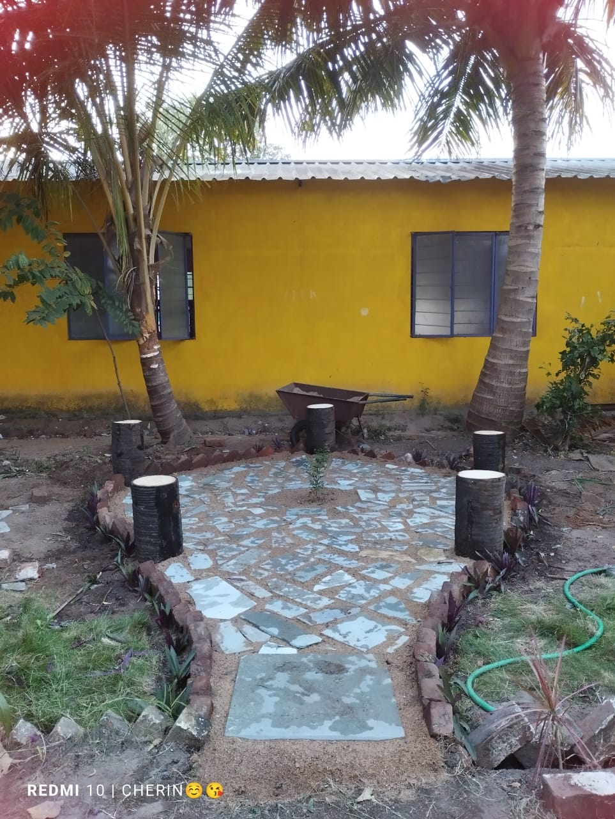

Students using coconut trunk seating in the Tea Garden model

9. Collaborations and Industry Interface
At the Pondicherry Institute of Agricultural Sciences (PIAS), industry engagement and academic collaboration are central to our vision of delivering career-ready, skill-based agricultural education. Recognizing the evolving needs of the agricultural sector, PIAS actively cultivates partnerships with research institutions, universities, industries, nurseries, and technology developers to bridge the gap between curriculum and practice.
Through collaborative efforts, students and faculty are provided with access to state-of-the-art research, modern farming techniques, and employment opportunities. These engagements also support curriculum enhancement, internship development, extension activities, and real-time exposure to technological innovations.

9.1. Campus Recruitment and Industry Placements
One of the major highlights of the academic year was the successful on-campus interview and placement drive conducted by UCAL – Drone Manufacturing Company, Chennai. This opportunity was instrumental in connecting students to cutting-edge agricultural technology sectors such as drone-based precision farming, aerial spraying, and agri-tech support services.

UCAL Placement Highlights:
- Campus interview conducted in January 2024
- Final-year diploma students participated in pre-placement training sessions, mock interviews, and skill assessments
- Shortlisted candidates received offer letters with placements in Chennai and surrounding regions
- Training support offered by faculty members from the Career Development Committee
This event marked a major step toward establishing PIAS as a talent hub for agriculture-related technologies and services, particularly in the domains of automation and digital agriculture.

9.1.1. Institutional Visits and Collaborations with Research Stations
To foster academic enhancement, PIAS has established strong academic relationships with national and regional agricultural research institutions. These collaborations aim to:
- Introduce students to research methodologies
- Provide access to demo farms and trial plots
- Facilitate joint workshops, extension activities, and internships

Key Institutional Collaborations

National Research Centre for Banana (NRCB), Trichy
- Students visited field trials on high-yield banana varieties, tissue culture labs, and post-harvest storage facilities
- Faculty engaged in discussions on collaborative research themes, including banana-based value chains and disease management
- Possibilities for future student internships and joint certification courses discussed

Tamil Nadu Agricultural University (TNAU), Coimbatore
- Engagement with faculty from Agronomy, Horticulture, and Agricultural Engineering departments
- Exposure to TNAU’s e-extension labs, soil testing centers, and research farms
- Discussions held on:
  - Sharing of curriculum innovations
  - Collaborative publications
  - Access to TNAU library and digital resources

Horticultural Research Station (HRS), Kodaikanal
- Study tour organized for second-year horticulture students in November 2023
- Sessions covered protected cultivation, cold-weather fruit crops, and ornamental plant breeding
- Introduction to clonal propagation and floral biotechnology techniques
- Informal MoU under review for faculty development and short-term training exchange

9.2. Additional Industry and Nursery Linkages
Beyond formal research institutions, PIAS has built working relationships with commercial farms, nurseries, and agri-service firms. These field partnerships allow students to observe enterprise models, develop entrepreneurial insights, and gain practical knowledge in:
- Nursery management
- Propagation techniques
- Organic input preparation
- Harvesting, packing, and marketing operations
Key partners include:
- Santhi Clonal Nursery, Vegakollai – Known for banana and guava saplings
- Private agri-input dealers for live demo sessions on biofertilizers and micronutrients
- Drone operators and agribusiness consultants for training modules on aerial mapping and data analysis

9.3. Benefits of Collaborations
The partnerships and outreach engagements have contributed to:
- Enhanced student confidence through real-world exposure
- Curriculum enrichment with insights from experts and ongoing projects
- Research opportunities in areas such as organic farming, biocontrol, and salinity tolerance
- Job creation and internships for graduating students
These industry-academic linkages directly support the institution’s mission of producing skilled, employable, and entrepreneurial agricultural professionals capable of thriving in both rural and corporate environments.

Table of Collaborations and Visits
Institution / Partner | Type of Collaboration | Focus Areas | Activities Conducted
UCAL, Chennai | Industry Placement | Drone Technology in Agriculture | Campus Interviews, Training, Job Offers
NRC Banana, Trichy | Research Collaboration | Tissue Culture, Banana Cultivation | Study Tour, Research Exposure
TNAU, Coimbatore | Academic Exchange | Agronomy, Soil Health, Organic Practices | Lab Visit, Curriculum Feedback, Workshop
HRS, Kodaikanal | Technical Visit & Informal MoU | Horticulture, Protected Cultivation | Field Training, Exposure Visit
Santhi Clonal Nursery, Vegakollai | Nursery Partnership | Sapling Propagation and Marketing | Internship, Field Demo

9.4. MoUs and Academic Collaborations

MoU Signed between Bharathidasan Government College for Women (BGCW) and PIAS. In a significant step toward strengthening inter-institutional academic cooperation, the Pondicherry Institute of Agricultural Sciences (PIAS) signed a Memorandum of Understanding (MoU) with Bharathidasan Government College for Women (Autonomous), Puducherry during the academic year 2023–2024.

Objectives of the MoU:
- To facilitate student internships and experiential learning opportunities for BGCW students at PIAS
- To conduct joint workshops, seminars, and field demonstrations in the areas of:
  - Organic farming
  - Vermicomposting and vermiwash production
  - Herbal gardening and medicinal plant cultivation
  - Bio-input preparation and usage
- To support faculty exchange programmes and promote collaborative project development

Scope of Collaboration:
- Field-based training sessions at PIAS for undergraduate and postgraduate students of BGCW
- Participation in extension and outreach activities, including farmer awareness camps and school eco-club visits
- Co-guidance of student research mini-projects, focusing on sustainable agricultural practices and climate-smart innovations
- Access to PIAS infrastructure including vermicompost units, herbal gardens, model farms, and bio-input labs

Impact and Relevance:
This partnership reflects the shared institutional goals of:
- Promoting practical agricultural education for women
- Creating career pathways in agri-based enterprises
- Encouraging research and skill development for rural sustainability
The MoU paves the way for future interdisciplinary research collaborations, joint student publications, and rural internship modules, benefiting both institutions and contributing to the broader development of Puducherry's academic and farming communities.
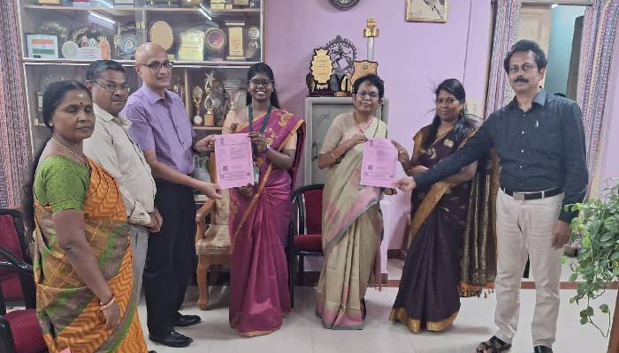

MoU signing ceremony with BGCW at PIAS

10. Student Development Programmes
At the Pondicherry Institute of Agricultural Sciences (PIAS), education is not limited to academic instruction—it extends into the personal growth, emotional well-being, and social development of every student. The institution strongly believes in nurturing students to become confident, compassionate, and capable individuals equipped to handle real-world challenges with clarity and resilience.
To achieve this, PIAS implements a variety of student development programmes, which include structured mentoring, value-based training sessions, self-awareness exercises, and material support initiatives. These programmes are aligned with the institution’s broader mission to provide value-based, holistic agricultural education.

10.1. “Who Am I?” – Self-Awareness and Identity Session
One of the most transformative programmes conducted at PIAS is the “Who Am I?” session, designed to help students explore their individual purpose, self-identity, strengths, and goals. This session is conducted annually for first-year students as part of their orientation programme and has received excellent feedback for its motivational and reflective value.

Session Objectives:
- Encourage students to reflect on their personal values and aspirations
- Help them identify strengths, weaknesses, and leadership potential
- Facilitate discussion on life purpose and the role of agriculture in society
- Create a safe space for sharing ideas, dreams, and concerns

Methodology:
- Ice-breaker activities and self-introduction rounds
- Guided introspection using structured worksheets
- Motivational talks by faculty and guest mentors
- Group sharing sessions to build mutual respect and empathy
Impact: Students reported a stronger sense of identity, improved self-confidence, and a more focused approach to learning and life planning after participating in the session.

10.2. Personal Counselling and Mentoring Support
PIAS recognizes that students come from diverse backgrounds, including many from rural, first-generation learner families. To support their emotional well-being, academic adjustment, and personal growth, the institute offers:

Personal Counselling Services:
- One-on-one counselling sessions led by faculty mentors and external professionals
- Support on issues related to academic pressure, peer relationships, stress, and goal setting
- Confidential and student-friendly process
- Focused support for students during exam stress periods

Group Mentoring:
- Faculty assigned as Class Mentors monitor academic and emotional progress
- Monthly interactive feedback sessions to discuss challenges and plan improvement
- Encouragement for peer mentoring and support circles
Outcome: The presence of a structured support system has significantly improved student engagement, class attendance, and interpersonal relationships on campus.

10.3. Leadership Workshops and Life Skills Training
To equip students with practical life skills, decision-making capabilities, and leadership qualities, the following workshops were conducted:

Key Activities:
- Leadership Skills Workshop: Focused on team dynamics, conflict resolution, and ethical leadership
- Communication and Public Speaking Sessions: To overcome hesitation and improve presentation skills
- Decision-Making and Time Management Modules: Real-life scenarios were used to teach time allocation, prioritization, and personal planning
Special guests from agri-business firms, local NGOs, and university alumni were invited to interact with students and share real-world challenges in the agriculture field.
These interventions have strengthened student confidence, encouraged initiative-taking, and prepared them to serve as ambassadors of sustainable agriculture in their communities.

10.4. Material Support: Uniform and Book Distribution
As part of its inclusive approach, PIAS provides essential academic materials and support to students, especially those from underprivileged backgrounds.

Support Offered:
- Uniform Distribution:
  - Each student receives two sets of uniforms designed for practical and classroom use
  - Promotes equality, discipline, and institutional identity on campus
- Book and Notebook Distribution:
  - Standard textbooks aligned with Annamalai University syllabus are provided
  - Practical notebooks and record books distributed semester-wise
  - Supplementary reading material on vermicomposting, mushroom cultivation, and value-added farming is also made available in the resource room
- Toolkits and Lab Essentials:
  - Selected students were provided with seed kits, pruning tools, and mini-lab items for use during field and lab sessions
Student Voices: The support has reduced the financial burden on families and helped maintain focus on studies without stress about academic expenses.

10.5. Holistic Growth and Outcome Focus
Through these student development programmes, PIAS ensures that every student:
- Gains self-awareness and clarity of goals
- Develops interpersonal and communication skills
- Learns to balance academic, emotional, and social responsibilities
- Is empowered to take leadership roles, both within and outside the institution
The institution’s approach recognizes that knowledge alone is not enough—character, confidence, and compassion are equally essential for success in today’s evolving agricultural landscape.

11. Infrastructure Enhancements
During the academic year 2023–2024, PIAS continued its strategic investment in infrastructure, focusing on learning-centric facilities, eco-friendly upgrades, and accessibility improvements. The goal was to transform the campus into a more dynamic, research-enabled, and student-responsive environment. These developments were executed under the guidance of Chairman Mr. C. Ganeche, with active involvement from faculty, farm assistants, and student volunteers.

11.1. Creation of Vermiwash Production Unit with Filtration Setup
Responding to increasing academic focus on natural farming inputs, PIAS established a dedicated vermiwash collection and filtration unit adjacent to the compost yard.
Key Features:
- Installation of PVC-based vermiwash extractors, layered with brick, sand, and charcoal filters
- Collection tanks with outlet valves for dilution experiments and foliar application studies
- Covered unit with signage used during student demonstrations and faculty-led research
- Integration with existing vermicomposting pits and leaf litter input trials
This infrastructure serves as a core practical module for plant nutrition classes and supports both research and value-added input production.

11.2. Restoration and Enhancement of Damaged Zones
Several infrastructural elements damaged due to monsoon rains and wear-and-tear were restored and upgraded:
- Re-laying of weathered pathways near the compost and herbal garden zones using anti-slip concrete tiles
- Replacement of broken water lines supplying the orchard and Azolla pond with new durable PVC pipelines
- Refurbishment of the nursery shade net house, which included frame strengthening and replacement of torn nets
These interventions ensured safety, continuity of practical sessions, and increased durability of campus facilities.

11.3. Establishment of Medicinal Plant Research Block
A new Medicinal Plant Research Block was created behind the herbal garden to support diploma projects and faculty trials on bioactive plants.
Plants Cultivated:
- Tulsi, Ashwagandha, Vetiver, Aloe Vera, and Kalmegh
- Tagged plots with QR-coded labels (experimental stage)
- Soil quality and growth data recorded by students under supervision
This area is now used for field documentation, phytochemical study planning, and exposure visits for external student groups.

11.4. Water Management Improvements
Recognizing the need for sustainable water use, the institute implemented:
- A semi-automated drip irrigation system for selected orchard lines (guava and coconut)
- Addition of a rainwater collection drum system near the polyhouse
- Water conservation posters and student-led awareness drives across the farm
These changes model climate-resilient water practices that are now referenced in curriculum and field demos.

11.5. Construction of Student Activity Pavilion (Open-Shed Zone)
To support outdoor teaching, demonstrations, and student gatherings:
- A thatched-roof, open pavilion was constructed near the farm block
- Equipped with cement benches, fan fixtures, and notice display space
- Used for group presentations, field briefing, and short training sessions for interns and farmer groups
This area promotes interactive learning in an open, natural setting, and supports the institution’s “learning beyond classroom” approach.

11.6. Impact of 2023–2024 Infrastructure Enhancements
The cumulative impact of these additions and restorations includes:
- Strengthened natural farming infrastructure, aligning with PIAS research goals
- Improved practical engagement and documentation for diploma projects
- Greater capacity to host visiting students, interns, and farmer delegations
- Reinforced the campus identity as a live demonstration site for eco-agriculture
These developments reflect the institute’s vision for resilient, learner-oriented infrastructure, and position PIAS for continued academic expansion and community relevance.

12. Way Forward: Future Vision
As the Pondicherry Institute of Agricultural Sciences (PIAS) progresses toward becoming a regional hub for practice-based, sustainable agricultural education, the institution’s vision continues to expand. The academic year 2023–2024 has laid a strong foundation for scaling up innovations, diversifying academic offerings, and expanding outreach to marginal and aspiring farmer communities.
Under the dynamic leadership of Chairman Mr. C. Ganeche, the institute continues to emphasize inclusive growth through education, skill training, and agri-entrepreneurship—anchored in natural farming values and green innovation.

12.1. Launch of Entrepreneurship-Focused Certificate Programmes
To meet the growing demand for agri-based startups and small-scale enterprises, PIAS launched new 3 to 6-month certificate courses, specifically designed for rural youth, SC/ST learners, and early-stage entrepreneurs.
Newly Introduced Programmes:
- Mushroom Cultivation & Processing
- Apiculture (Beekeeping & Honey Processing)
- Value-Added Millet Products
- Herbal Soap & Natural Cosmetics Making
- Nursery Techniques & Plant Propagation
Highlights:
- Conducted in collaboration with CEAD, local FPOs, and experienced practitioners
- Blended delivery: on-campus sessions + practical workshops + demo unit visits
- Over 100 participants trained, including visiting students and farmers
These micro-courses not only offer livelihood enhancement pathways, but also function as pre-incubation training for future agri-business innovators.

12.2. Initiation of Agri-Innovation & Training Center (AITC)
In 2023–2024, groundwork began for establishing the Agri-Innovation & Training Center (AITC)—a precursor to the Agri-Business Incubation Cell (ABIC). The AITC functions as a bridge between classroom knowledge and entrepreneurial field application.
Key Developments:
- Setting up of mini-production units for compost packaging, microgreen trays, and herbal kits
- Business model workshops led by invited resource persons from FSSAI, PM-FME, and NABARD
- Student involvement in label design, pricing strategy, and customer outreach
This center supports students in "learning to earn", encouraging them to think beyond academics and into value-chain thinking.

12.3. Expansion of Student Research Culture
Building on the 2022–23 momentum, the student research ecosystem expanded this year with:
- Over 15 mini-projects on topics such as:
  - Vermiwash on okra growth
  - Organic treatments for nursery pest control
  - Growth of microgreens under shade net conditions
- Introduction of "Research Buddy System"—pairing juniors with seniors for field documentation
- Hosting of the First Internal Research Poster Exhibition in March 2024
- Drafting of student submissions to CEAD Bulletin and youth agri-innovation portals
Faculty also conducted review and mentoring sessions to refine research methodology and writing.

12.4. Strengthening of Eco-Friendly and Climate-Responsive Farming Models
In line with climate-smart goals, PIAS undertook the following actions:
- Established a Rain-fed Millet Demonstration Plot using native varieties of kodo and little millet
- Developed a Student-led Model Farm Unit showcasing:
  - Mixed cropping with bio-inputs
  - Indigenous pest repellent formulations (neem-garlic extract)
  - Crop spacing trials for soil moisture retention
In collaboration with Pondicherry University and TNAU, PIAS also began:
- Initial trials on legume-based intercrops for degraded lands
- Herbal bund planting (lemon grass, tulsi) for pest deterrence
These models serve as open labs for rural visitors, interns, and diploma students.

12.5. Preparing for Degree Programme Expansion
The academic team at PIAS, in consultation with external experts, began drafting:
- The Detailed Project Report (DPR) for B.Sc. Agriculture and B.Sc. Horticulture
- Proposed syllabus structure aligned with ICAR 5th Dean’s Committee
- Faculty recruitment plans and lab expansion strategy
Liaison was initiated with Pondicherry University and the Directorate of Higher Education to discuss formal affiliation.

12.6. Conclusion: Nurturing the Next Generation of Green Leaders

Institutional Reflection – 2023–2024
This year, PIAS made remarkable strides in aligning education with entrepreneurship, in-field research with documentation, and community engagement with sustainability. Every student project, training, and outreach event reflected our core value: “Educate, Empower, and Enrich.”

Award for Best Educational Institution – 2023–2024
We are proud to announce that Puducherry Agricultural Science College, functioning under the Pondicherry Agricultural Science Movement, was honored with the Best Educational Institution Award during the 9th State Conference of the Agricultural Science Movement – Tamil Nadu, held in Chennai on December 18, 2023.
The award was presented in recognition of the colleges:
- Commitment to practical, eco-friendly agricultural education
- Innovative integration of farm-based learning and rural outreach
- Active promotion of sustainable farming models and student entrepreneurship
The award was conferred by:
- The Hon’ble Vice-Chancellor of Tamil Nadu Dr. J. Jayalalithaa Fisheries University
- The Registrar of Tamil Nadu Dr. M.G.R. Medical University
The award was received with pride by Dr. J. Jeyakumar, Director of the Pondicherry Agricultural Science Movement and Principal of the College. This achievement marks a milestone in our continued journey toward academic excellence, grassroots transformation, and agri-leadership development in the region.

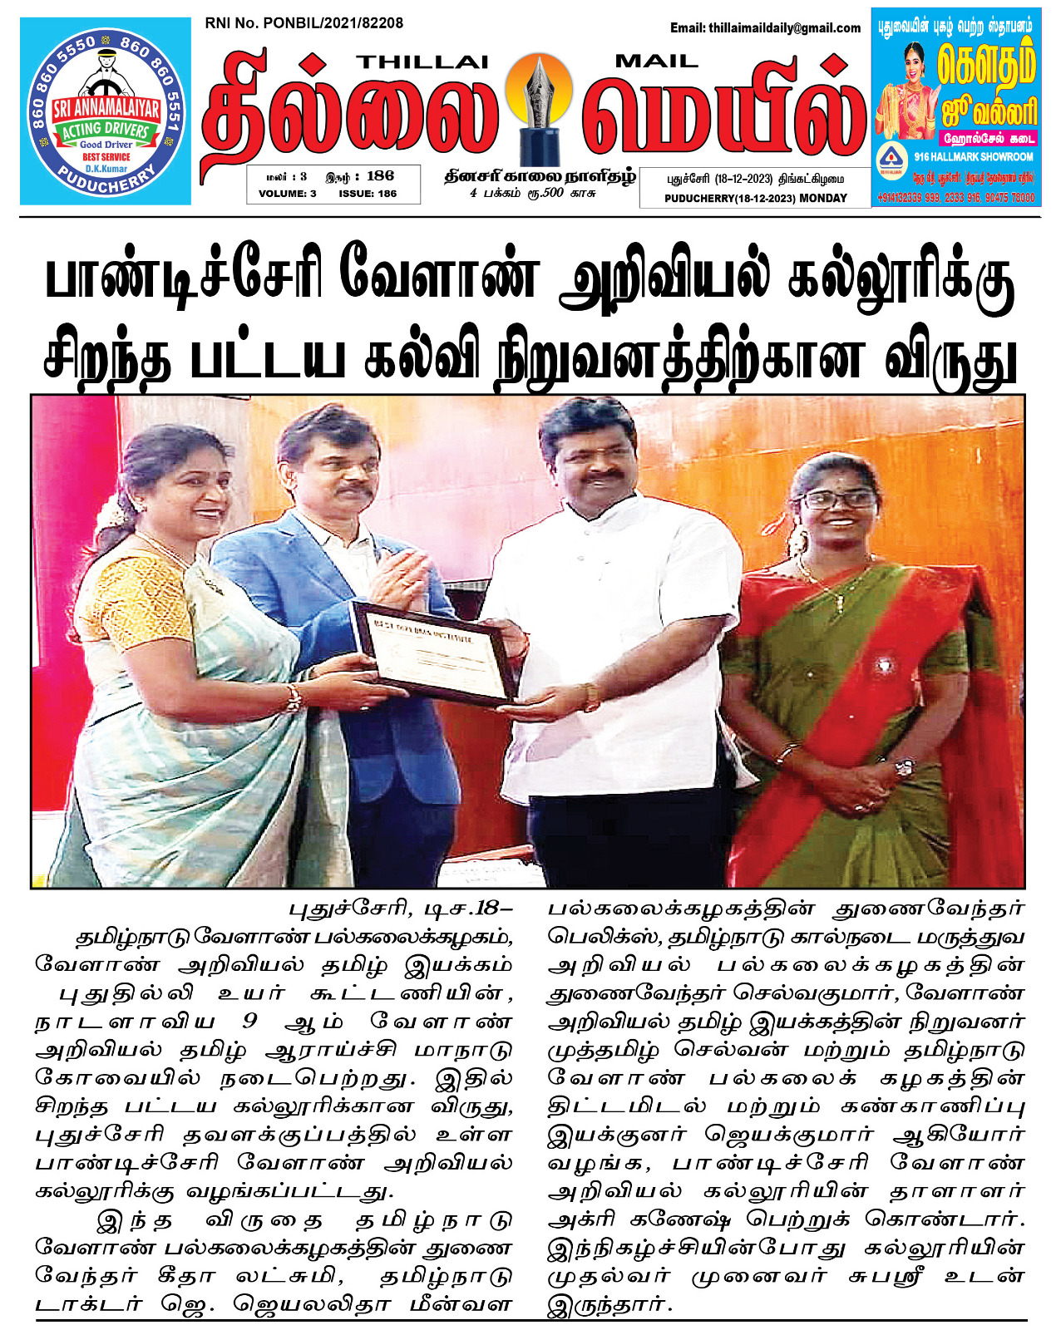

Gratitude and Acknowledgement
We extend sincere thanks to:
- Our visionary Chairman Mr. C. Ganeche for his leadership
- Dedicated faculty and supporting staff
- Our committed students and interns
- Partners such as CEAD, KVKs, Pondicherry University, NABARD, and local FPOs
- Government departments and CSR partners for their ongoing support

Final Note
At PIAS, learning is not confined to classrooms—it thrives in every farm bed, compost trench, and student idea. As we look ahead, we reaffirm our promise to cultivate knowledge that serves the land, empowers youth, and uplifts rural livelihoods.
– Team PIAS

